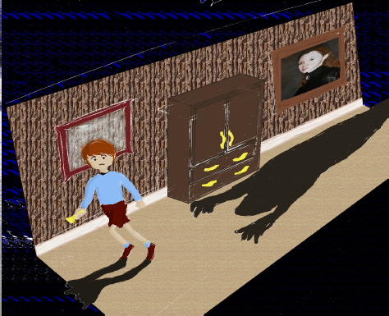

**Continuum**

*There’s a time and place for everything…*

Sam Assaf  
Alex Attar  
David Campbell  
Ralph D'Almeida

13 August 2012

**Executive Summary**

*Continuum* is a puzzle game in which the player guides a young boy through an old haunted house to the safety of the attic. To do so, the player must solve puzzles by travelling in time through portraits and teleporting from wardrobe to wardrobe, all while staying clear of the evil shadows that roam the house. Intended for all ages, *Continuum* will hook the player with increasingly challenging puzzles and innovative mechanics.

**Overview**

*Continuum* is a 2D side-scrolling puzzle game for the Xbox 360, aimed at players 12 and up who are fans of a Tim Burton-esque setting. Playing like a cross between *Portal* and *Amnesia: The Dark Descent*, the player controls a boy who finds himself in a run-down haunted house occupied by strange shadows and talking portraits. The boy is told by the portrait to make his way to the attic where he will be safe from the shadowy inhabitants. To reach the safety of the attic, the player will have to solve intricate puzzles using three items of furniture at his disposal: the talking portrait, the wardrobes and the chairs.

The wardrobes allow the boy to teleport from one location to another. By entering one wardrobe, the boy will exit from the matching wardrobe. In order to reach new locations in the house, the boy can move these wardrobes around.

The boy can enter the portraits to travel back in time, allowing for him to switch between the current run down state of the house and the pristine condition that the house was originally in. In the current state, staircases can be broken and rubble may block the boy’s path. In the past, the rubble will disappear and staircases will be fixed, but broken walls will also be restored. The player will have to constantly switch between the present and the past in order to reach the attic, bearing in mind that any changes made to the house in the past will affect the present state of the house, while the reverse is not true. In the final level, the boy will also be able to travel back to a third time frame, when the house was still being built, meaning that some objects will be in their original condition while others will not have been built yet.

Finally, the boy can use his unexplained ability to manipulate the chairs to distract the shadows as he moves around the house. Shadows will either stand still or patrol an area. While they do not exist in the past, it is not always possible to enter a portrait in order to avoid them. As an alternative, the boy can pick up chairs and move them around the house to draw the shadows away from the places that they are guarding. The boy must remain cautious however, as patrolling shadows will eventually return to their original location.

These three puzzle solving mechanics and the ways in which they interact constitute *Continuum*’s most original offering. While numerous 2D side scrolling puzzle games exists, the combination of time travel and teleportation make *Continuum* unique. Teleporting is not a unique feature on its own, but when combined with the ability to dynamically alter the state of the world it becomes very interesting. The notion of the past affecting the present but the present not affecting the past means that the player must always be aware of the state in which the changes to the world are being made. As such, the player must not only determine the series of wardrobe and chair manipulations to perform, but the state in which to perform them. The fact that these three mechanics do not have to be used together but instead can function individually is also critical. The optional interconnection of mechanics makes puzzle difficulty simple to adjust; by altering the degree of interaction between the different mechanics, the puzzle can be made easier or more difficult. This gives *Continuum* a very smooth increase in perceived difficulty as the game progresses.

The plot in *Continuum* also constitutes a point of interest. As the game progresses, the player discovers more about the main characters in the game. Initially, the player knows nothing about the character or the setting in which the game takes place; the player assumes that the setting is a generic one of a boy in a haunted house. However, as more of the mechanics are introduced, the player discovers that the boy is actually a ghost that inhabits the house, while the shadows are actually people that wish to move in and renovate it. This twist explains the boy’s mysterious abilities to teleport and control furniture as well as the portraits’ interest in protecting him. This interesting twist makes reference to certain well-known movies such as *The Others, Beetlejuice and* Casper. This unexpected twist in the plot keeps the player interested and allows for *Continuum* to be more than a simple puzzle game.

In addition to the aforementioned movies which help form *Continuum’s* setting, the game also borrows aspects from a few well-known games. Although these games vary in genre and tone, *Continuum* shares some common features with Portal 2, Quantum Conundrum and Limbo among others.

In *Portal 2*, the player controls the main character through a series of puzzle chambers. Using a portal gun to create spherical portals, the player must teleport between different areas of the map to solve unique and addictive puzzles. As the player progresses through the game, more puzzle solving items are unlocked for the player to use. Like *Portal 2*, *Continuum* focuses on puzzle solving using unique items, one of which (the wardrobe) behaves similarly to the portal gun. As in *Portal 2*, new mechanics are introduced as the game progresses. Unlike *Portal 2*, *Continuum* takes place in a darker setting and as such does not place an emphasis on humour. Finally, *Continuum* is a 2D side-scrolling puzzle whereas *Portal 2* is a 3D game.

In *Quantum Conundrum*, the player controls a young boy who must be guided through different puzzles in a large mansion. Different sections of the mansion have different properties, and the player must complete puzzles in four different dimensions: the Fluffy dimension where all objects are light, the Heavy dimension where objects become heavier and more durable, the Slow dimension in which time is slowed by a factor of ten, and finally the Reverse Gravity dimension where all objects experience a reversal in the direction of gravity. Later in the game, the player gains the ability to switch between these different dimensions at will. Like *Quantum Conundrum*, *Continuum* also bases puzzle solving on switching between different states in which objects behave differently. Although *Quantum Conundrum* places less of a focus on humour than *Portal 2*, *Continuum* places even less of a focus on humour, and is also not in 3D.

In *Limbo*, the player guides a young boy through a strange and dark environment. Through trial and error, the player learns to navigate an extremely harsh world where almost anything can cause the main character's demise. Like *Limbo*, *Continuum* also revolves around guiding a young boy through a hazardous and relatively unknown environment. Whereas *Limbo* focuses on puzzles where the player is expected to die numerous times, *Continuum* instead uses a more traditional puzzle solving where the player is expected to solve the puzzle in a few attempts; the goal is to discover the solution through thought, not trial and error. Frequent gruesome deaths play a large part in *Limbo's* setting and puzzle mechanic, but *Continuum* will not contain such graphic content, nor will it place such a large emphasis on the artistic aspect.

Overall, *Continuum* will seek to captivate the players of all ages with its challenging puzzles, its simple gameplay and its interesting story. While the game bears some similarities to other puzzle games such as *Portal 2*, *Quantum Continuum* and *Limbo*, the combination of original mechanics, good level design and a mysterious setting will ensure that *Continuum* constitutes a unique and worthwhile offering for fans of puzzle games and a Tim Burton-esque setting.

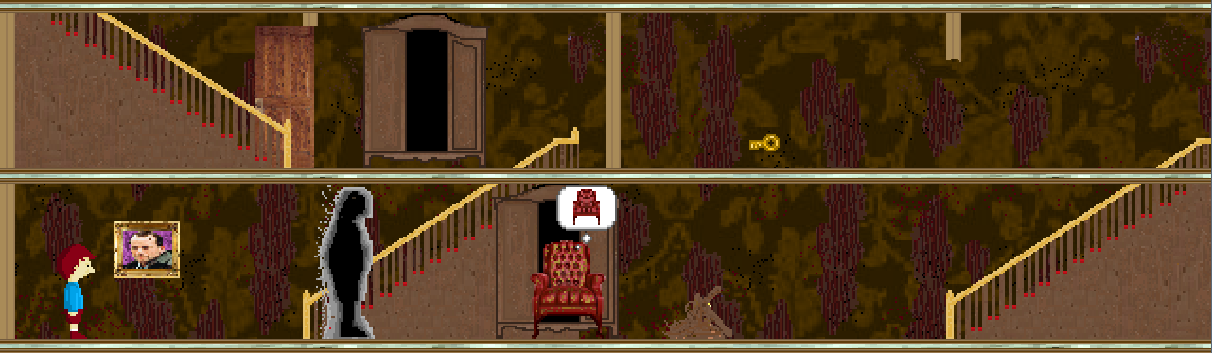

*Figure 1:**A sample screenshot of Continuum taken in the present state, featuring a portrait, a shadow, two wardrobes, a door and key, a rubble pile and a chair.*

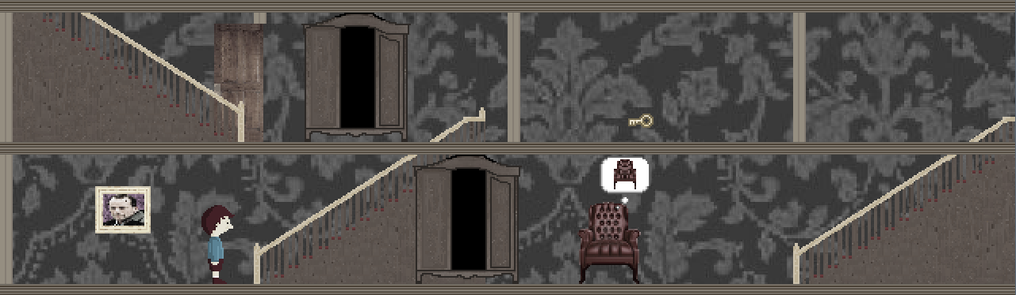

*Figure 2:**A sample screenshot of Continuum taken in the past state, featuring a portrait, two wardrobes, a door and key, and a chair. When compared with Figure 1, we can see that the broken wall on the second floor has been fixed and that the rubble pile has disappeared.*

**Related games**

**Portal 2 (2011)**

Valve

First Person Puzzle-Platform game for PS3, Xbox 360, PC, and Mac

In *Portal 2*, the player controls the main character through a series of puzzle chambers using a portal gun. This gun allows the player to create spherical portals on surfaces, and as such allows the player to teleport between different areas of the map all while conserving velocity. Using these portals, the player can also move objects or even laser beams from one area of the world to another. Taking advantage of this mechanic, the player must complete a number of test chambers, each of which features a unique puzzles involving water hazards, enemies and laser activated switches to name a few. New mechanics such as the repulsion gel, the propulsion gel and the conversion gel are introduced as the game progresses, leading to increasingly challenging and complex puzzles. The puzzle element of Portal 2 constitutes the primary similarity to *Continuum*, while the style constitutes the primary difference.

Like *Portal 2*, *Continuum*’s gameplay revolves around puzzle solving using an array of mechanics. In each the level, the player will have to use a combination of objects to solve the puzzle and reach the next level, eventually completing the game. Like Portal, the game is broken into small and discontinuous puzzles that do not affect each other. The puzzles also become increasingly challenging as the game progresses and more mechanics are introduced. This game design concept is a key feature implemented by *Continuum*.

*Portal 2* and *Continuum* primarily differ in setting and style. *Portal 2* places a large emphasis on humour and the game is known for its dark comedy. The contrast between the lighthearted and darker sides of Portal 2 give it a very unique setting. *Continuum*, on the other hand, will not place any focus on humour and will not feature a strange juxtaposition of light and dark elements. Instead, *Continuum*’s style falls somewhere between the darkest and lightest aspects of Portal. Other key differences between the games include *Continuum’s* 2D setting and reduced scale.

Portal 2 was extremely well received by critics, receiving multiple Game-of-the-Year awards and selling approximately 4 million copies worldwide. Among its many notable qualities, reviewers particularly enjoyed the quality of the puzzles, the comedic value of the script, the excellent plot development and the overall polish of the game.

The puzzles in Portal 2 were incredibly engaging. As a sequel to Portal, Portal 2 added new mechanics such as the various gels and the excursion funnel to increase the possible complexity of puzzles. The player started off only being able to use the portal gun. After a certain number of puzzle chambers, a new mechanic would be introduced to the player. The first few puzzles after the introduction of the new mechanic would drop in complexity, allowing the player to learn how to use the new tool. After a certain number of puzzles, the difficulty would jump back up and the new mechanic would begin being used with the existing mechanics. By the end of the game, the player had a large array of puzzle solving tools at his disposal, and the time just to determine the goal of the puzzle became more considerable. Timing also became more important in later levels. In all, the puzzles were refreshing, complex and increased in difficulty at a very steady pace, giving the player an extreme sense of accomplishment after completing the game.

The comedic value of the script was also crucial to the game’s success. Contrary to many puzzle games (and even most games in general), Portal 2 placed a large emphasis on the comedic entertainment value of the game. The humour was mostly supplied by the character of GLaDOS, the evil computer forcing the player to complete the test chambers. With a unique combination of dry, dark and sarcastic humour, GLaDOS kept the player entertained while solving the puzzle, offering entertaining running commentary which prevented the game from getting stale in slower stretches. Overall, the humour present in Portal 2 was a key element to its success.

Considering that most reviewers referred to the game as nearly-perfect, there are no real failures to speak of. One of the few things to be critiqued was the replay value of the game. Like most puzzle games, the value of playing the game a second time is put into question. Although the puzzles are extremely engaging, they do not change the second time through the game, and so the only reason to play through the game again is either to re-experience the game or to try and improve your completion time. The online multiplayer mode extends the life of the game, but since the level creator is only available on the PC version, console gamers do not have the ability to play the large amount of user created levels that exist. As such, replay value is the only real aspect of Portal 2 that can be criticized, but not only is this common among puzzle games but also only applies to console gamers.

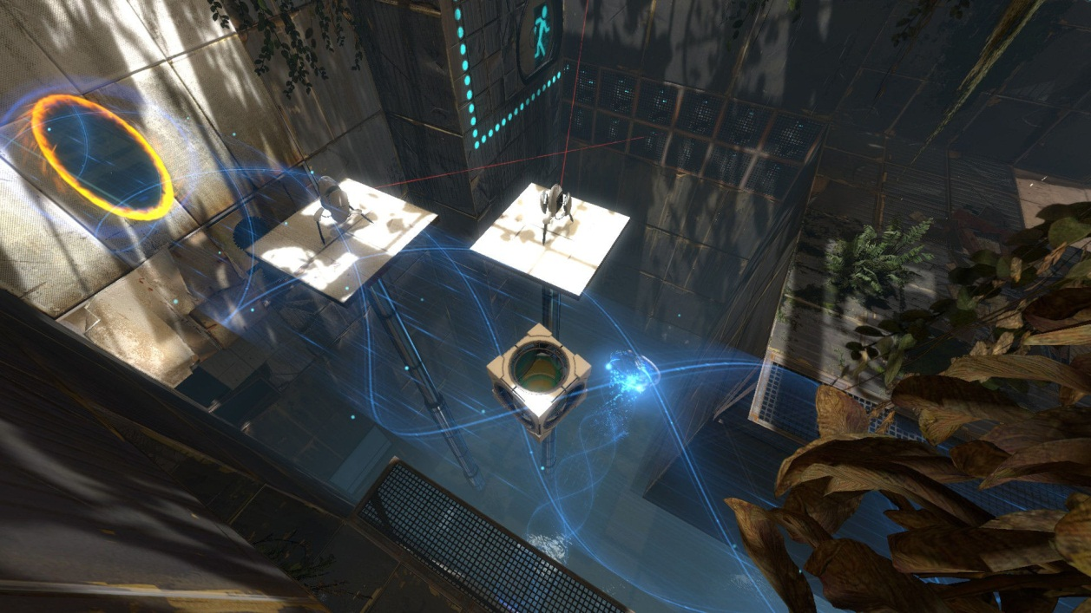

**Limbo (2010)**

Playdead

Third Person Side Scrolling Puzzle Horror for PS3, Xbox 360, PC, and Mac

In *Limbo*, the player guides a young boy through a strange and dark environment. The player is not given any background as to the origins of the character or even the setting of the game. Instead, through trial and error the player learns to navigate an extremely harsh world where almost anything can cause the main character's demise. Scattered throughout the world are traps that can kill the boy, and so the player must discover how to progress through the game while keeping the boy alive. With its very simple gameplay, beautiful art and dark setting, *Limbo* draws the player in and slowly reveals the story behind the game. *Limbo* and *Continuum* share certain puzzle and setting elements, but the styles in which these elements are presented vary.

Like *Limbo*, *Continuum* also revolves around guiding a young boy through a hazardous and relatively unknown environment. The player must solve puzzles in order to progress through the game, all while avoiding the shadows. Just as in *Limbo*, the plot is slowly revealed to the player, and strange hints or apparent breaches in continuity entice the player to keep playing.

Whereas *Limbo* focuses on puzzles during which the player is expected to die numerous times, *Continuum* instead uses a more traditional puzzle solving style where the player is expected to solve the puzzle in a few attempts. *Limbo* places a large emphasis on discovering solutions through frequent and gruesome deaths, but *Continuum* instead employs a traditional puzzle solving style that does not conflict with the target audience. Players can employ trial and error techniques if they choose, but *Continuum* provides the player with enough information about the puzzle for it to be solved in a single attempt. Due to a much smaller production scale and lack of any artists, *Continuum* also employs a much simpler art style.

*Limbo* was extremely well received by critics, receiving multiple Game-of-the-Year awards and art awards. As an indie game, *Limbo* had slightly more humble sales than more commercial games, but still managed to sell over one million copies, becoming one of the top 15 all-time best-selling games on Xbox Live Arcade in the process. Among its many notable qualities, players and critics particularly enjoyed the artistic presentation and the quality of the puzzles.

Without a doubt, the most recognizable and one of the most important aspects of *Limbo* is the artistic presentation. There is no confusing *Limbo* with any other game; the visuals are just that unique. The black and white images, use of blurring effects and incredibly fluid animation draw the player into the disturbing game world and never let the player go. While the visuals are fantastic in their own right, the sound design in *Limbo* is also incredible. The absence of any music adds to the mystery of the game world and the clarity of the sound effects immerse the player but also provide vital clues as to how to proceed. While *Limbo* offers much more than just a good looking game, the art plays an extremely important part in both setting the tone of the game and keeping the player immersed.

Given that *Limbo* is a puzzle game, the puzzles are also one of the defining features of Limbo. Based on a very simple control scheme, *Limbo* allows the player to interact with the world in a very simple manner. While the puzzles vary tremendously, interacting with the world remains extremely intuitive. With this simple interaction mechanism set in place, the player is free to solve the wide array of trial-and-death based puzzles. The disturbing game world is filled with hazards that will gruesomely put an end to the player’s life. Using only the visual and audio clues at his disposal, the player must try to move as far through the game as possible before inevitably dying. After this, the player restarts just prior to his death, and attempts to move passed this point based on information discovered during his previous failure to do so. Although the player dies repeatedly, the developers manage to keep the game from becoming frustrating all while challenging the player with diverse puzzle mechanics which sometimes include other humans and giant spiders. In all, the puzzles in Limbo and the trial-and-death game mechanic complement the presentation perfectly, and lead to an extremely immersive game.

As with most Game-of-the-Year winning games, there is very little to criticize in *Limbo*. In fact, one of the only prevailing criticisms of the game is its length. *Limbo* is a fairly short game and can be completed in six or seven hours. Being such an immersive and enjoyable game to play, players feel that the game ends too quickly. Although there are many hidden trophies to discover in the game, the experience comes to an end fairly quickly and there is nothing new experienced playing the game a second time. As stated previously, this is a common problem with puzzle games, and the replay value can almost always be put into question, and this is the case with *Limbo*. However, this is the only real criticism, and many would agree that it is better for a game to end too quickly than to drag on after it has grown stale.

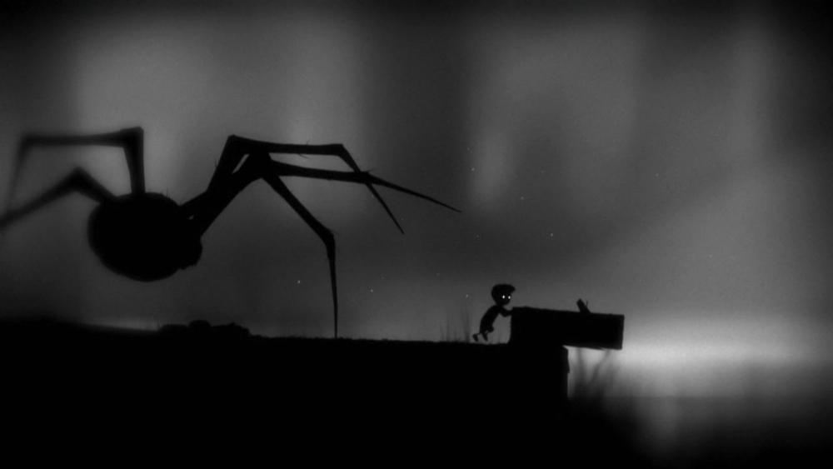

**Amnesia: The Dark Descent (2010)**

Frictional Games

First-Person Survival-Horror game for PC, Mac and Linux

In *Amnesia: The Dark Descent*, the main character Daniel awakes in a strange castle. Discovering a note that he's written telling himself to find and kill the master of the castle, Daniel must work his way through the castle to discover who its master is, why he needs to kill him and how he got to the castle in the first place. Because the castle is filled with mutated and murderous creatures, Daniel will not only have to find answers to the questions that haunt him, but he will have to watch his back while doing so. The main similarities between *Amnesia: The Dark Descent* and *Continuum* are the mysterious setting and the importance of non-offensive objects at the player’s disposal.

In *Amnesia: The Dark Descent*, the player begins the game knowing nothing about the character or the back story. With only the note to push the player onward, all that the player learns about the setting and the characters is learned playing the game. In a similar manner, the story of *Continuum* will develop as the player plays through the game. The player initially knows nothing about the boy, the portraits, the shadows or anything else, but as he progresses through the game the entire back story will be revealed.

In *Amnesia: The Dark Descent*, the player is given nothing to defend himself with. While navigating through the castle, any encounter with a monster will prove fatal. As a result, the player must be very cautious when exploring the rooms, and must use his cunning to discover the secrets of the castle while avoiding any encounters with its inhabitants. In the same way, *Continuum* also forces the player to avoid enemies rather than confront them. Using the wardrobes, portraits and chairs, the player must maneuver around the shadows, as any contact between a shadow and the boy will result in restarting a puzzle.

In the end, the main difference between *Amnesia: The Dark Descent* and *Continuum* is the genre. While *Amnesia: The Dark Descent* is a survival horror game based on scaring the player, *Continuum* is a puzzle game that focuses on challenging the player intellectually. As such, the target audiences are also very different.

*Amnesia: The Dark Descent* has been extremely well received by critics with some critics even going as far as saying that it is the best horror game ever created. The cited strengths of this game were the minimalist gameplay, as well as the counter-intuitive inability to fight, while the most recurring negative aspects of the game was the game’s physics and replay value. Although sales in the first month were low, they quickly went up in the months following its release and even continued to rise over a year later, with recorded sales of about 400,000 units. For an independent horror title, these sales figures make *Amnesia* a financial success. That said, *Continuum* is expected to share many of the same strengths since it also features minimalist gameplay mechanics and enemies which cannot be directly engaged.

There isn’t anything complicated about *Amnesia*'s gameplay mechanics, and the game does a great job at utilizing and combining the handful of simple mechanics offered. The player simply moves through the house, interacting with objects along the way. One of the few real abilities given to the player is the ability to use a lantern to light the different rooms of the castle. The ability to create such a great experience with such simple and limited mechanics is where *Continuum*’s focus lies. The biggest challenge is the ability to make puzzles engaging enough without boring the player with repetitious procedures.

The fact that the monsters in *Amnesia* cannot be attacked constitutes another of the game's main selling points. The monsters in *Amnesia* are extremely scary and add so much to the tone of the game. Because they cannot be killed, the player must avoid them at all cost and run away if ever encountered. This inability to attack the enemies contributes so much to the feel of the game. Not being able to engage in combat means that the player feels an incredible amount of relief when he manages to evade them. Not only does this contribute to the game's disturbing atmosphere, but the relief of surviving is much greater than any triumph that would be felt killing a monster. If the player had the ability to kill the monsters, they would not be considered as threatening to the player, and more skilled players might be tempted to seek out the monsters to kill them, which would completely rob the game of its entire feel. The innovative idea of invulnerable enemies in a game is definitely one of the strong points that *Continuum* hopes to implement.

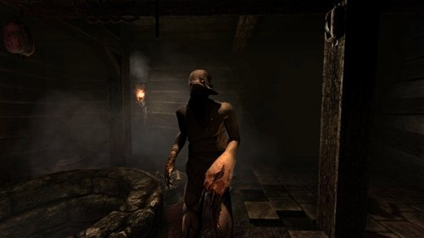 The game’s aesthetics and use of graphics were universally praised but the overly-accurate use of physics did come at the expense of control. As one of its key mechanics, the player has the ability to interact with and use various items in the environment. However, this ability to interact with many of the objects in a supposedly intuitive manner occasionally caused slight issues. Players would sometimes be required to move or rotate items with awkward mouse gestures, and these control elements were disturbed the player's immersion in the game. While these controls did occasionally frustrate players, they were not distracting enough to cause players to exit the game, and did not discourage players from replaying the game after its completion. However, with only six to eight hours required to complete the game, its replay value is questionable. Like with most puzzle games, the puzzles don’t change the second time through. One of the few reasons to play the game a second time is to try to finish the game faster than during the first play-through. Another reason is to play the game again following the developers' advice to play the whole game with the lights off and headphones on. In all, while *Amnesia* is considered a great horror game, it is not without its flaws, and *Continuum* will try to avoid making the same mistakes.

**Quantum Conundrum (2012)**

Airtight Games

First Person Puzzle Game for PS3, Xbox 360 and PC

In *Quantum Conundrum*, the main character controls a young boy who has gone to visit his uncle. However, his uncle, a professor and inventor, is in the middle of performing experiments when he arrives and the experiment unfortunately goes wrong. The uncle becomes trapped somewhere in the house and the player must go through the mansion and find a way to release him. In order to do this, the player will have to solve multiple puzzles involving different dimensions. The player is given a glove which allows the player to switch between four different dimensions: the Fluffy dimension where all objects are light, the Heavy dimension where objects become heavier and more durable, the Slow dimension in which time is slowed by a factor of ten, and finally the Reverse Gravity dimension where all objects experience a reversal in the direction of gravity. The main similarities between *Quantum Conundrum* and *Continuum* are the use of world state alteration in puzzle solving and while the tone consists of the main difference between the two games.

In *Quantum Conundrum*, the main puzzle solving mechanic is the alteration of the world state using the inter-dimensional shift glove. In order to access new locations in the mansion, the player will have to switch back and forth between the four dimensions, altering object properties in the process, but not the player’s properties. Initially, the player is limited in which dimensions he can travel, but as the game progresses he unlocks the ability to switch between them at will. Like *Quantum Conundrum, Continuum* also places an emphasis on solving puzzles through an alteration of the world state, in this case using the portraits that allow time travel to take place. All puzzles in *Quantum Conundrum* must be solved by switching dimension many times in order to benefit from specific object properties for specific tasks. This is similar in *Continuum,* the main difference being that the game world alteration is used to change the world you’re interacting with, not the objects that you’re interacting with. However, the concepts are similar.

The main difference between the two games is the tone in which these puzzles take place. While neither game has a particularly dark tone, *Quantum Conundrum* employs a much lighter tone than *Continuum.* In *Quantum Conundrum*, the lighter tone is reflected throughout the game, from the lighthearted commentary provided by the uncle, to the cartoonish visuals and sound effects. Continuum, on the other hand, sets a somewhat more serious tone using darker (albeit simple) visuals, more haunting music and a more serious story line. While the gameplay mechanics in the games are similar, the ways in which they are presented constitute the main difference between the two games.

*Quantum Conundrum* received good reviews and was generally well appreciated by gamers. *Quantum Conundrum* received an average score of 81% on Meta Critic, with 90% as the highest score and 67% as the lowest score. As a fairly recent downloadable game, the sale totals have not yet been made available. However, given the good reviews and well known creator (Kim Swift, developer on *Portal* and *Left 4 Dead*), it is reasonable to assume that *Quantum Conundrum* has known relatively good sales numbers. Among the qualities highlighted by the critics, the most prevalent quality is the game’s interesting puzzles while its main downside is the lack of polish.

*Quantum Conundrum*’s main appealing feature is not surprisingly the quality of the puzzles. FILL WITH DESCRIPTION OF PUZZLES. TODO

*Quantum Conundrum*’s most disappointing feature is its lack of polish. While the puzzles are appealing, the game lacks a certain polish found in similar games like *Portal*. The visuals are nice and colourful, but are not incredibly detailed. The voice acting is good, but not as good as the voice acting in *Portal 2*, nor is it as funny. Also, the story develops nicely, but the game is widely criticized for its ending. Finally, while the puzzles are good, the increase in difficulty is not as smooth as it should be, and as such some of the early puzzles when a mechanic is introduced are trivial. In all, the game has some good elements but lacks some overall polish when compared to its close competitors.

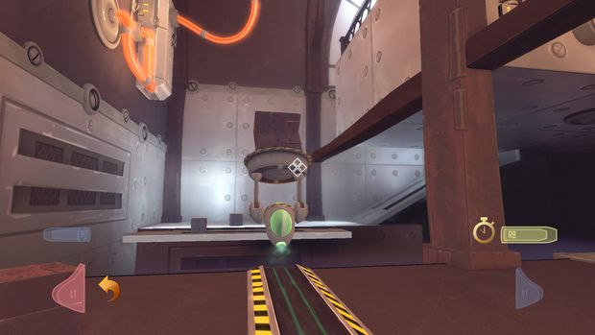

**Player composites**

*Continuum* is aimed at players of age 12 and up who enjoy puzzle games and mysterious settings. Here are a few of the types of players that the game targets.

Alex Sinclair is a 15 year old student currently attending senior high school. Alex is a good student who places a priority on school work. During his summers and other times away from class, he likes to play first person puzzle games like *Portal* and *Quantum Conundrum*, or fully immerse himself in expansive role playing games like *Elder Scrolls,* although he does this less than he used to. Alex enjoys the challenge that puzzle games provide, as well as the fantastic settings found in RPGs. When he’s too busy with school during the year to fully immerse himself in large-scale games, he enjoys playing quick matches of Call of Duty and Smash Brothers online. Alex has an Xbox 360 plugged into his computer monitor in his bedroom and a Wii in the family room. Most of the games that he owns are birthday or Christmas presents. Alex plays large scale games alone and action games online with other players, in addition to occasionally playing local multiplayer games at friendly get-togethers. Alex also enjoys playing soccer and hockey with his friends, as well as watching Montreal Canadiens games during the year. In all, Alex is a fairly busy individual who enjoys playing a wide variety of games depending on the time of the year; he likes playing very light action games during the school year, puzzle games during breaks and large scale role-playing games during the summer.

Brian Quincy is a 39 year old currently working as a high school math teacher. He is married and has an 11 year old daughter. Although Brian doesn’t have much time for games, he does enjoy occasionally playing very light games and considers himself a casual gamer. Brian has a long history of playing games and in his youth enjoyed classics puzzle and adventure games such as *Wario’s Woods* for the NES, *Hugo’s House of Horrors* for PC and *Myst* for PC. Brian enjoys playing other genres of games as well, but buying games that are also appropriate for his daughter to play has become one of his main concerns. Brian is primarily a PC gamer, playing old DOS games with DOS-Box and playing old console games on emulators. However, he recently bought and Xbox 360 Kinect bundle for his daughter. Brian mostly plays games on his own, although he occasionally plays local multiplayer games on Kinect with his daughter. Brian owns a 37” HDTV in his living room, although he uses it primarily to watch movies with his family or the occasional game show. Overall, Brian is a casual gamer looking for mentally stimulating but not overly time consuming games that both he and his daughter can enjoy.

Audrey Sylvester is a 17 year old high school student currently in senior high school. Audrey is part of the school’s art program and has been heavily involved is set design and artwork in the school plays and musicals. She is an active artist outside of school as well and spends most of her money or art supplies. She is a fan of American cinema, in particular of Tim Burton’s and M. Night Shyamalan’s work. Her favorite movies include *Nightmare before Christmas*, *Sixth Sense,* and *The Others*. Her older brother owns an Xbox 360 that is set up in the family room. Audrey is a very casual gamer and rarely plays video games, at most once or twice a month. The few games that she does play are mostly owned by her brother, although her parents have bought her a few games over the years. In fact, one of the few games that she has ever truly gotten into is *Limbo*. However, since completing *Limbo* she has become interested in finding more games with similar tones and settings. In all, Audrey is not someone that spends more time creating art and watching movies than playing games, but she is interested by games with interesting settings.

Felix Epson is a 10 year old boy in elementary school. Interested in most subjects, Felix is a fairly good student. However, his favorite subject is computing and he enjoys working on the school computers. When he finishes his computing work early, he enjoys playing platform and puzzle games on Miniclip.com. Felix owns an Xbox 360 that is connected to the family television. His parents buy him new games a few times a year, although they also encourage him to engage in other activities besides gaming. Felix enjoys playing puzzle games, platform games and sports games a few times a week for thirty to sixty minutes per session. He enjoys playing multiplayer games with his friends, but he mostly plays on his own. Felix does not get too immersed in games, and looks primarily for games that are fun to play, regardless of what the setting is. His favorite television shows are *The Simpsons* and *SpongeBob SquarePants*. Overall, Felix is a casual gamer who enjoys a variety of different game genres, but is not looking for something that requires much immersion to enjoy.

**World**

*Continuum* takes place in a modern day United States of America, in the state of Rhode Island. The game world is close to a normal world, the only difference being that ghosts exist. The mansion in which the action takes place is a 95 year old house, built by the Pershing family.

William and Margaret Pershing married in August of 1916. William, the son of a wealthy industrialist and a successful businessman himself, was wealthy enough to have a mansion constructed for him and his bride. Wanting to raise a family, William and Margaret decided to have the mansion built in a secluded area of Rhode Island. As architectural enthusiasts, William had the house designed in the style of the Breakers, a large Vanderbilt mansion built in the late 1800s. In addition to the style, William had another request. Fearing that the turmoil affecting Europe would spread to North America, William specified that a large safe room be built on the top floor of the house.

Because of unusually cold winter weather that year, construction of the mansion was halted during the winter months and did not recommence until March of 1917. Around the same time, the United States of America declared war on Germany and William was enlisted to join the troops. In his absence, the mansion was completed and Margaret moved into to it. In June, Margaret gave birth to a son and named him Bruce in honor of William’s father.

Although William returned home from the war, he was permanently scarred by what he experienced in Europe. Having witnessed many of his fellow soldiers die in a surprise mustard gas attack in addition to the numerous other horrors of trench warfare, William was never able to reconnect to his family. Haunted by the memories of war, William became silent and secluded. Convinced that she could help him rediscover who he once was, Margaret became almost entirely cut off from the rest of the world and put most of her effort into helping William. Her efforts failed and William died at an early age, completely disconnected from the world around him. However, having left a part of himself in Europe, William did not truly die but instead became a little more than a spirit that wandered the house aimlessly as he had done near the end of his life. Deeply affected by the death of her husband, Margaret began to battle depression. Exhausted by the effort required to raise a son on her own and attempt to help her husband, she became frail. In a moment of weakness, she gave into her depressive thoughts and committed suicide. Having given a part of herself to William, Margaret did not die either, but instead became a ghost just as William had.

Left alone to fend for himself and having never met anyone but his parents, Bruce did his best to take care of himself. However, he had always been cared for by his mother and thus was unprepared to fend for himself. He eventually ran out of food and starved to death. Having been robbed of a normal childhood, Bruce too became a ghost. Because Bruce never met anyone his own age, he assumed that what he was living was normal and so became a ghost without ever realizing it. He continued living as he had, playing games in the different rooms of the mansion and reading books.

Separated from his body and mind at death, William’s psychological wounds were eventually healed at which point his soul began to long for Margaret. Searching the house for her he discovered that she too had become a ghost and they were reunited. Upon reuniting, the two realized to their horror that they had completely failed as parents and had abandoned Bruce to his death. Longing to be with him but too ashamed to reveal themselves to him, William and Margaret chose to inhabit portraits of themselves. Living in portraits, they were able to keep an eye on him without revealing themselves.

Having been built in such a secluded area, the house was ignored for a very long time. People who did come across the mansion were not sure to whom it belonged. Eventually, the story came out that a family had lived there in the early 1900s but had all died early and mysterious deaths. People became convinced that the house was haunted and as such most who came across it from that point onward made a point to avoid it from then on. Kids in the area began to dare themselves to enter it (though none ever did).

In 2012, a couple visiting Rhode Island became enamored with the state and the architecture of the older buildings which it contained. Upon exploring the different parts of Rhode Island, they stumbled across the Pershing mansion. The couple was immediately drawn to the house’s design and was surprised to discover that no one owned it. Upon making further enquiries with the town officials, they were told that the house was indeed empty, though not for sale. Because the couple was very rich, they were able to bribe town officials into letting them purchase the house.

A few days later, the couple visited their newly acquired home with a group of renovators in order to assess its state and determine how extensive the renovations would have to be. When they entered the house, they were shocked to discover the poor state that it was in. Each member of the party went to examine a different part of the house, but in doing so alerted William and Margaret of their presence. Fearing that Bruce would no longer be safe with intruders in the house, William decided to reveal himself to Bruce in order to guide him to safety. It is at this point that *Continuum* begins.

**Characters**

The main characters in *Continuum* are Bruce Pershing, the people in the portraits (William and Margaret Pershing), and the shadows.

Bruce Pershing is *Continuum*'s protagonist. He is a 95 year old ghost, although he has conserved the appearance he had at death as a 9 year old boy. He has medium-length brown hair, brown eyes and a pale complexion. He wears a light blue sweater and brown shorts, with brown dress shoes.

Bruce was born in 1917 and died in 1926 after both his mother and father passed away without leaving anyone to watch over him. Even when they were alive, Bruce was so secluded from the world that he never met a human being besides his parents. Growing up in such a strange environment without any point of reference, Bruce believed everything happening to be normal and so never really questioned his parents' disappearance. Left all alone, Bruce eventually died of starvation. Not knowing what death really was, Bruce never realized he had died and instead continued living as a ghost as he had as a child.

Bruce's only motivation in the game is to follow the portraits order to get to safety. Although he is not exactly sure why, he recognizes the portraits voice and hopes to find out more about his identity. Feeling that the portrait has his best interest at heart, Bruce is motivated to get to the safety of the safe room on the top floor of the house.

Bruce died at an early age without experiencing many of the normal things that children experience, and as such has no particular likes or dislikes. Because his mother taught him to read while she was still alive, he spends most of this time reading books found around the house. He also engages in games with involving different pieces of furniture. This is how Bruce first discovered many of his special abilities. Being a ghost, the only thing limiting Bruce is his imagination. He is able to move chairs with his mind because he is a ghost, and discovers this playing around the house. He can also move the wardrobes with his mind, but because he has never tried to do so and does not realize that he is a ghost, he instead moves them with his body. However, because he is a ghost, he is able to move the wardrobes with no effort. After reading *The Lion, the Witch and the Wardrobe*, he attempts to travel to Narnia by entering one of the wardrobes. Having no physical limitations preventing him from doing so, he discovers instead that he can travel from one wardrobe to another. However, because he still thinks that he is alive, he doesn't walk though doors or walls, and he fears the shadows which he believes can harm him.

Other than his parents, Bruce has no family, and given that he never met anyone else while he was alive, has no friends either. His only enemies are the shadows, and although he trusts the portraits, he does not know enough about them to consider them friends.

William Pershing is Bruce's father. William was born in 1891, son of Bruce (senior) and Elizabeth Pershing. William was home schooled and learned business under his father's tutelage. William was a striking young man with dark brown hair, dark brown eyes and a tanned complexion. Physically strong and mentally sharp, William met Margaret and they married in August of 1916.

William was passionate about business and enjoyed sport. Gifted with a strong sense of leadership, William was a perfect fit for the army and enlisted when the United States of America declared war on Germany. William also had a strong sense of right and wrong, and was outraged by Germany's attacks on ships not involved in the war. William also disliked the increasing hostility of the world, and lived in fear that it would spread to North America.

William returned home from war shattered by the experience and never recovered. He died at the age of 29 and became a ghost. Eventually recovering from the trauma of war after his death, William chose to inhabit portraits of himself to keep an eye on Bruce. However, being too embarrassed of his failure as a father, he chose not to reveal himself to Bruce until the shadows appeared.

William's main motivation is to guide Bruce to safety. Because William died at such a young age, his memory of the past is still fresh and using this memory, he can take Bruce back in time and show him how the house was when he was younger. The past that he allows Bruce to travel in is actually just his memory, not the actual past. The only reason that changes made by Bruce in the past affect the present state of the house is that Bruce believes himself to be travelling back in time. As such, he interacts with the house as though he is in the past when really he remains in the present. Since none of the obstacles in the present can actually stop him (he is a ghost, he can just pass through rubble), he is able to perform in the present what he thinks he is performing in the past. By using his memory of the past, Bruce essentially rids Bruce of any of the mental blocks that would prevent from moving forward in the present.

Margaret Pershing (born Wilson) is Bruce's mother. Margaret was born in 1896, son of Woodrow and Mary Wilson. Margaret was schooled at the local convent. Margaret was a beatiful woman with auburn hair, dark brown eyes and striking facial features. She met William at a social event and they married in August of 1916.

Margaret enjoyed studying art and architecture. She was also an avid reader and enjoyed the works of Edgar Allen Poe. She was a kind hearted woman who also had a strong sense of right and wrong. She encouraged William to enlist in the war effort as both of them felt that it was the right thing to do. Seeing her husband shattered by the experience, she felt guilty for ever suggesting he enlisted and put much of her effort into helping him recover from his trauma. When he died, she became extremely depressed and blamed herself for his death. Becoming more and more dejected, she eventually gave into her thoughts and committed suicide. Being reunited with William after death and seeing him fully recovered from his trauma, she began to desire to draw closer to Bruce. However, being too embarrassed to reveal herself to the son that she left to die, she chose to hide in portraits of herself like William. However, riddled with guilt, she chooses not to reveal herself to Bruce until it is absolutely necessary.

Margaret's main motivation is also to guide Bruce to safety. However, because she feels ashamed of her failure as a parent, she waits until the end of the game to do so. Because she was around when the house was being built, she can bring Bruce back to a state of the house that William never witnessed.

The shadows are the antagonists of *Continuum*. They are actually humans that have come to inspect the house that has just been purchased by the couple visiting Rhode Island. Their goal is to determine what repairs will need to be done on the house in order for it to be good enough condition to be inhabited.

The shadows have the general silhouette of a human, but lack any clear features. Instead, they looks like clouds of smoke. When they move, they leave a trail of smoke behind them. They cannot see Bruce but they can see the effects that he has on the objects in the house, and they can hear the sounds that he makes. If they collide with Bruce, they become aware of his presence.

**Progression graph**

Ending cut scene

Level 3

Complete the puzzle

Complete the puzzle

Who is she? What is she sorry for? How does she know my name?

"Press the two buttons to open the safe room. I'm sorry I'm in no state to help you, although I never was, was I?

What does he mean?

Enter the safe room

Complete the puzzle

Unlock the safe room

Travel back further in time

"I can take you back further than William can. I'm sorry Bruce"

Meet the woman portrait

Complete part of the puzzle

Level 4

Complete the puzzle

I'm not the stranger?

"Goodness, more strangers!"

Level 2

Complete the puzzle

Move first wardrobe

"Changes in the past will affect the future"

Level 1

Move first chair

"You'll have to distract that shadowy figure with the chair"

Bo back through portrait

"The wall has reappeared"

Enter first portrait

Enter first wardrobe

"You won't be safe here, get moving"

"The staircase wasn't always broken"

Beginning

Meet the male portrait

**Art direction**

With *Continuum*, the visuals consist of a mix of realistic and cartoonish art. The determining idea was to have moving characters (both playable and non-playable) be portrayed with a more cartoon style. As the game ended up only having two characters, Bruce and the shadows are the characters that demonstrate this idea.

Bruce is a silent main character in *Continuum*, and although he is involved in a tragic story, he is a very simple character. Being abandoned by his parents at an early age having never come into contact with other people, Bruce is a very simple character even if his story is not. The visuals reflect this nature. Bruce is drawn with a significantly oversized head and very little facial detail, a common visual style seen in such games as *A Boy and His Blob*, *Limbo,* and the *Smash Bros*. franchise when portraying characters from the *EarthBound* series (most recently Ness and Lucas). There is nothing intricate about his appearance, and not only does this match his personality, but it also makes him easy to draw and animate.

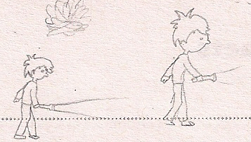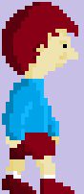

*Figure 3: Original concept art for Bruce and his in-game rendition.*

For the shadow, the idea was to have it be a fairly mysterious looking character; it should not look exactly like a monster, or a ghost or a human, but instead something like a cross between the three. As you can see in the game, the shadow has a fairly human profile that is just slightly distorted to confuse the player about its nature. To further confuse the player, the shadow moves not by walking but by instead gliding across the floor. The original idea was to have the shadow walk normally, but by instead having it glide, its nature is not so clear to the user. To add some effect to its sliding, the shadow leaves a trail of what looks like smoke behind it as it moves.

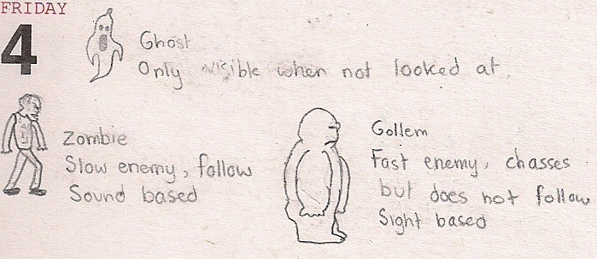

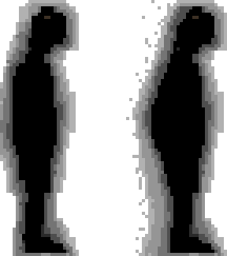

*Figure 4: Original sketches for monsters in the game. However, when it was decided that Bruce was actually a ghost and that the monsters were actually human, the design was completely changed.*

For all other items in the game including the portraits and the various items of furniture, the idea was to have them look as realistic as possible. Cartoonish visuals are very nice when they work, but the problem is that the player can become confused about the objects that he's looking at if the drawing is not done well enough, not to mention that the visuals will not look appealing if the style is at all inconsistent. To stop this problem from occurring, the remaining visuals were instead designed to look as realistic as possible by taking real images and altering them to fit the need of the game. As such, each of the images in the game started out as a real image of an object, and was edited to have the right look, size and feel. For example, in the case of the portrait, a picture of a picture frame was taken and scaled down to size. In MS Paint, the colors were modified to make the frame look more vibrant. Once this was done, the picture of a woman was taken and scaled down to size and placed inside the frame. The extreme amount of scaling means that although the people and objects do not look like photographs anymore, they look much more realistic than they would have looked had they been drawn by hand (especially with regards to the textures and the lighting).

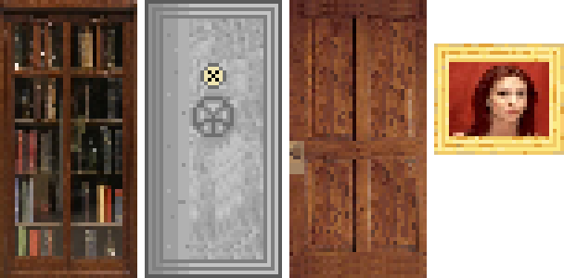

*Figure 5: (Bookcase, safe door, open door and woman portrait). Some of the items found in Continuum. Each item in the game began as an image of a real object with the exception of the safe door, the staircase, the button, the rubble pile and the floor.*

One of the key elements of *Continuum*'s artistic direction was the existence of the objects in multiple states. Because the player can travel back in time, each of the objects must be represented in multiple states of use. To do this, each object in the game is saved in two states: the present state and the past state. Objects in the past are much newer and as such show less wear than their current states. To create this difference in states, the same base drawing was used in both cases. After the past state had been created, dirt was added to the object, colors were faded and in some cases parts of the object were removed or broken. In the case of the floor, the asbestos between the floors of the house can e seen. This helps the player to distinguish which state he is in currently, in addition to ensuring continuity in the game.

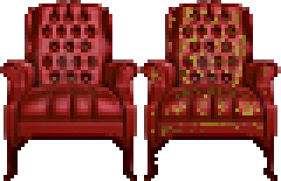

*Figure 6: Comparison of the chair in past and present states. In the present state, the chair's leather is peeling off, the cushion is much dirtier and the legs are chipped.*

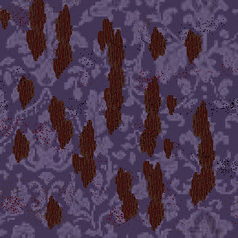

*Figure 7: Comparison of the wallpaper in past and present states. In the present state, parts of the wall paper have been torn off and specs of dirt cover the pattern.*

To further highlight the differences between the past and the present, a grayscale effect was also added to the game. Even with the different states of the objects, the look of the past and the present was too similar. The game revolves around constantly switching between these two states, and so it was necessary that they be extremely easy to tell apart. To achieve this, the amount of color present in the past state was removed. As such, when the player enters the past, the game visuals look as though they have been passed through some sort of filter. In the distant past (when player's enter the woman's portrait), color is drained almost entirely.

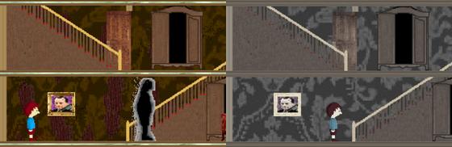

*Figure 8: Comparison between the saturation in the past and the present.*

A similar effect was used to differentiate between different levels. The entire game takes place in a house and the same objects are present in every room, so it is necessary for there to be some way to differentiate the levels from one another. To achieve this, each level has its own tint. As such, although the objects and wallpaper are the same, the background color of the world changes from level to level.

**UI storyboards**

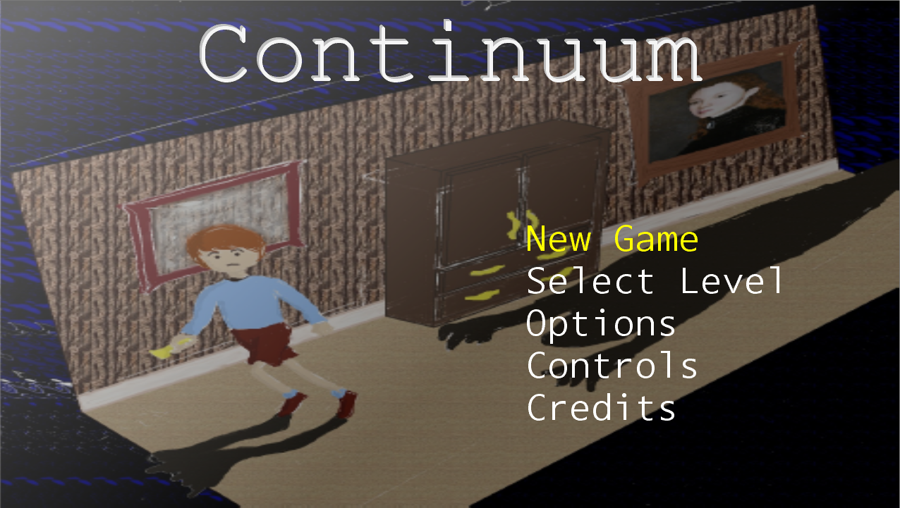

*Figure 9: Main menu screen*

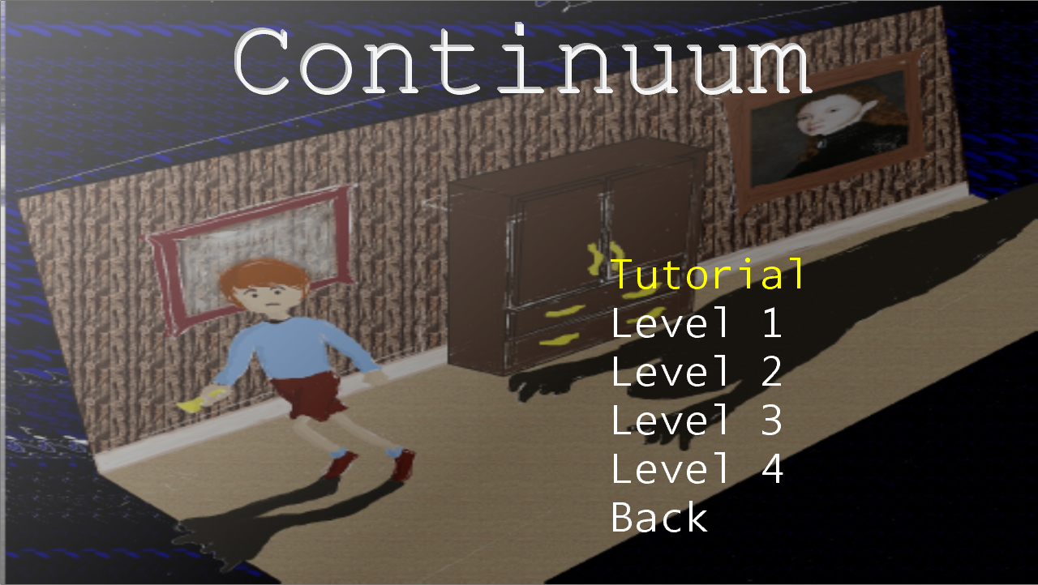

*Figure 10: Level selection screen*

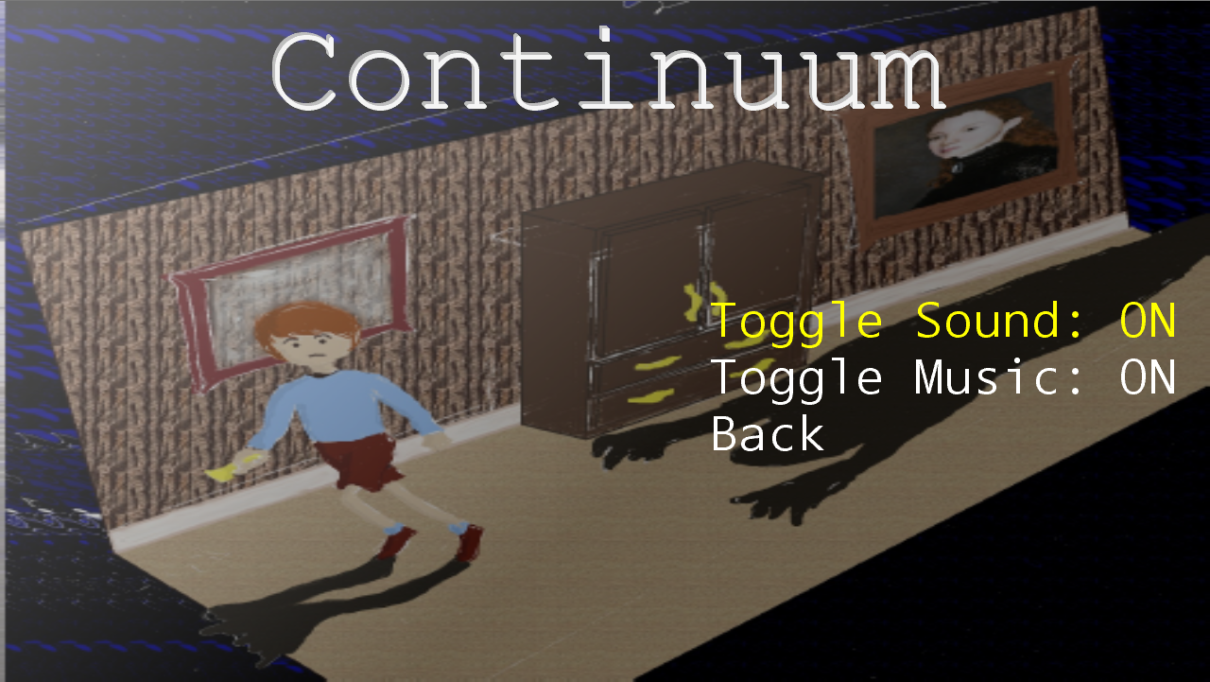

*Figure 11: Option screen*

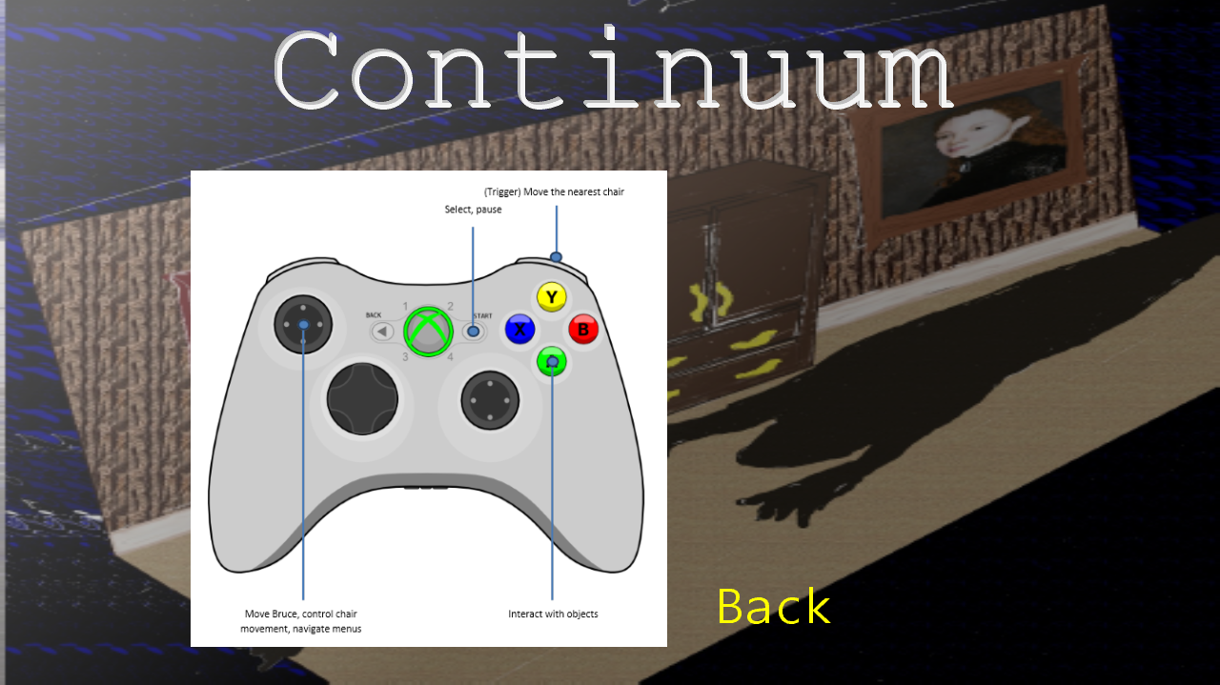

*Figure 12: Controls screen*

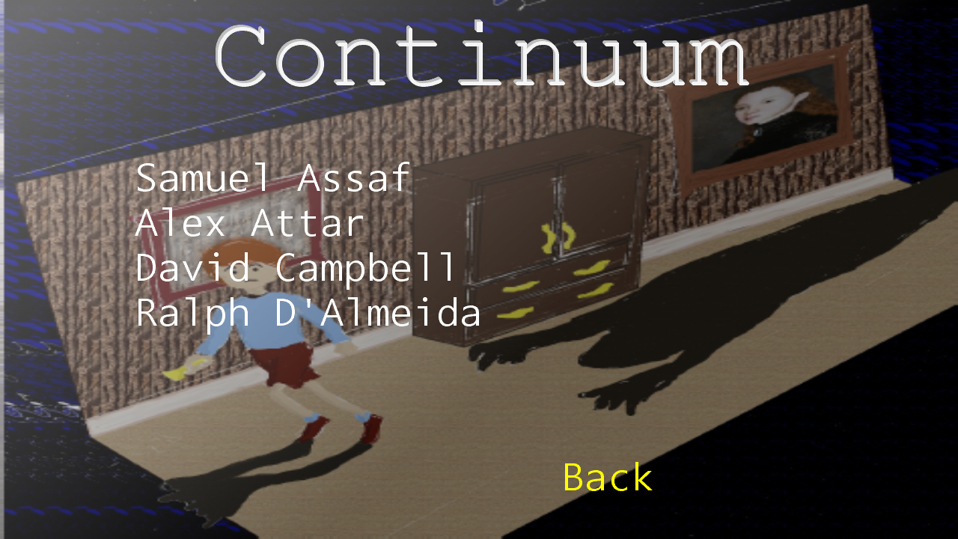

*Figure 13: Credits Screen*

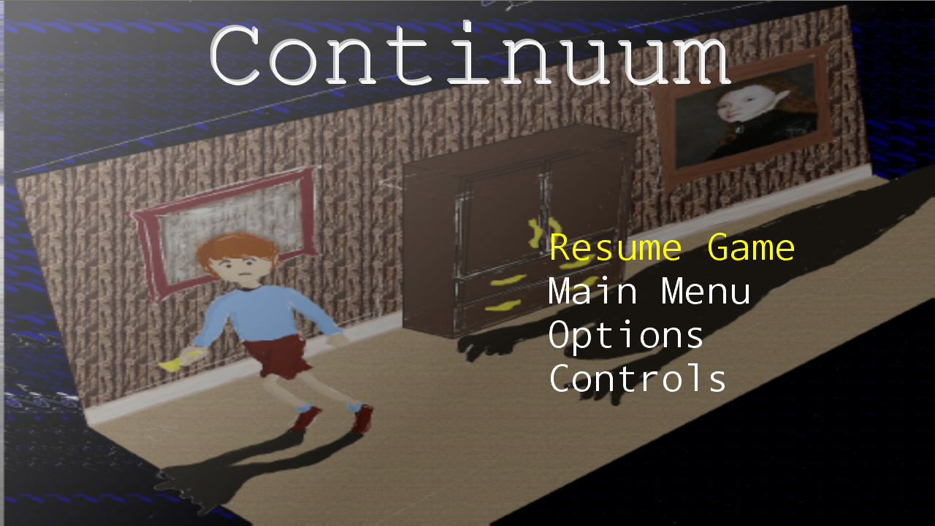

*Figure 14: In-game pause screen*

Select Level

Main Menu

Controls

Options

Options

Controls

Credits

Pause Menu

Level 2

Level 1

Tutorial Level

End

Level 4

Level 3

**Tags and dialogue**

PortraitWelcome: "Well, well. It would appear that there are strangers in the house. You won't be safe here boy so get moving."

TravelToPast: "That staircase wasn't always broken. Come into my portrait and I'll show you how it once was."

TravelToPresent: "Of course, broken walls have not yet been broken. Jump in to travel back to the present."

MeetShadow: "That shadowy figure doesn't seem to be able to see you. However, he'll definitely notice you if you try to walk past. You'll have to distract him with something to get the key. Careful though, he'll certainly notice the wardrobe door opening."

MovingWardrobe: "The past isn't just useful for restoring staircases or clearing rubble. The shadows will disappear, and any changes you make here will affect the current state of the house."

Level2: "Goodness, more strangers. Be careful not to get too close."

Level3: "Let me clear this rubble for you."

MovingPortrait: "Oh, that's right. I forgot I wasn't always down there. Sorry."

Level5: "There's a safe room at the end of the top floor. You'll need to press both blue buttons to reveal it. I'm sorry I'm not in a position to help you ... not that I ever was, was I?"

FemalePortrait: "You might need my help for this. I can take you back to when the house was still being built, which William cannot. Bruce ... Bruce I'm so sorry ..."

Level5Checkpoint: "Almost there Bruce, you'll be safe in a minute."

CutScene: "Brucie, you're safe now. Everything's going to be fine."

**Technology plan**

*Continuum* is a side scrolling 2D puzzle game that employs simple but unique mechanics. For these two reasons, the game will be coded from scratch by the development team, only using a simple framework as a starting point. The simplicity of the game means that the benefits of using an existing engine or making a mod of another game would be outweighed by the costs. *Continuum* does not use any advanced physics, it does not employ complex artificial intelligence, it uses very basic visuals and only has five levels. As a result of these aspects, licensing costs to use an existing would completely outweigh any of the benefits.

The code will be written entirely using Microsoft Visual Studio 2010 (C#) as an IDE. The framework on which the game is built is Microsoft XNA 4.0. Given that the game was to be developped on the Xbox 360, the combination of MS Visual Studio and MS XNA made the most sense.

In order to share the code among developers, a repository was created and hosted by Google Code. Developers used an Apache Subversion repository for version control. Google code was chosen for many reasons. In addition to being free and easy to use, it provided more than enough space to store all of the needed content for such a small game.

The art for the game was created using Microsoft Paint and Gimp 2.0. As with most of the software, Paint and Gimp were chosen for their ease of access and simplicity. Both Gimp and Paint are free to use, and given the simplicity of *Continuum*'s art, they provided more than enough features.

The design document was created and placed on the repository for everyone to work on as the game was being developed. Given that everyone had to be able to make changes to the document, Microsoft Word was used. Other options considered were using LaTeX and simply using a text file. Although LaTeX is free and can be used to create very professional looking documents, it was not chosen because of the learning curve related to the software. Everyone is familiar with Microsoft Word, whereas very few people have previously used LaTeX. To avoid having to teach developers the basic features of LaTeX, MS Word was chosen instead. Word was also chosen over the use of text files for the formatting options. Although a text file is simpler to use, its contents would had to have been copied to some word processing software before printing anyway. To avoid the intermediate step, Word was chosen over Notepad.

In terms of hardware, the game was developed using PCs running Microsoft Windows 7. The game was initially run on PC, before eventually being ported to the Xbox 360. For Xbox testing, a standard Xbox was connected to a PC and was run using an XNA Creator's Club account.

**Software architecture**

The software architecture used is a modified version of the data centered style because of its flexibility and performance. It offers easy integration of the game’s different components. That is, the clients are independent of each other and the data store is independent of the clients. For instance, changing our 2D graphics logical module to a 3D graphics logical module will not break the functioning of the game logic.

In fact, all the game components gravitate around a shared data store and each one is required to retrieve all information it needs to update and draw itself. However, in our model, the components don’t save back their updated information; instead, they keep them in memory for speed performance (decrease traffic between a client and the data store). Hence, we chose a simple repository as a style of communication between each component and the data.

For all components to communicate with each other directly, we group them according to their functionality into sub-groups.

The overall architecture is presented below:

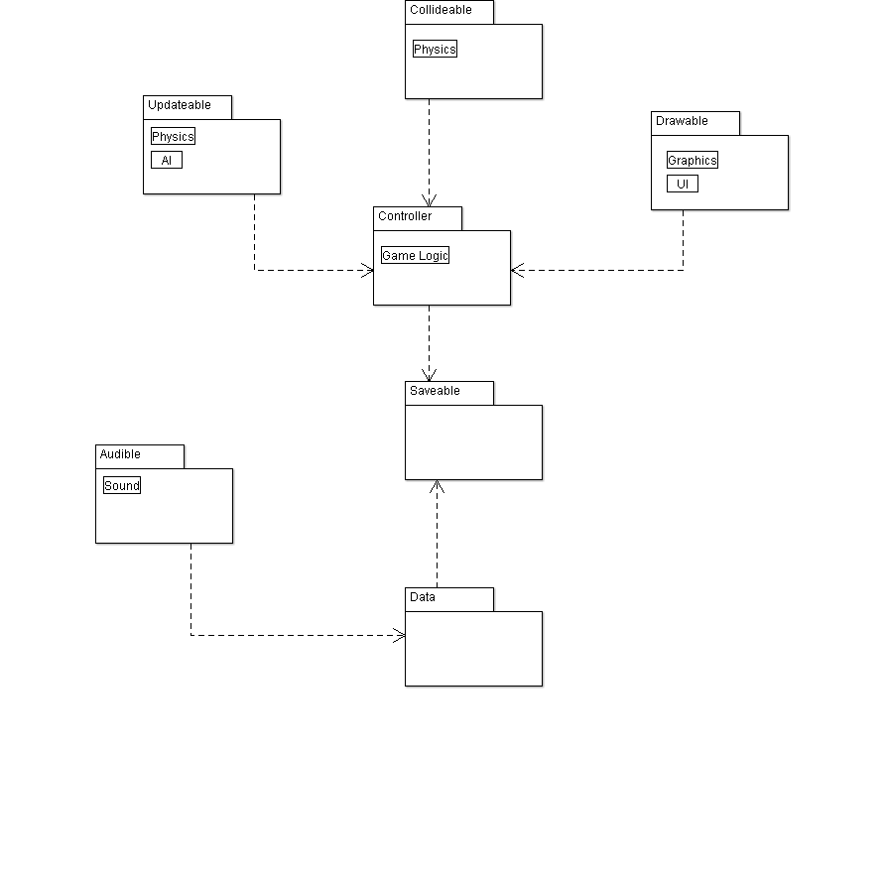

From the above architecture, we build the following class diagram that shows all the major components, modules, data, and control flow.

TODO: UML

**Controls**

Select, pause

(Trigger) Move the nearest chair

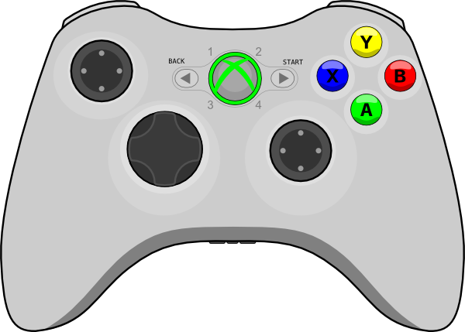

Move Bruce, control chair movement, navigate menus

Interact with objects

**Level design**

Tutorial

The tutorial level was designed in a way that all of the game’s major mechanics and a tiny bit of the backstory would be sufficiently introduced without really challenging the player at all. Bruce starts out in a section of the house where only one shadow is present on the upper floor. The staircase is broken and there is one pair of open wardrobes in addition to one locked wardrobe with a nearby key which leads out of the tutorial. The use of the first two wardrobes evidently trivial since the only use is to show the player that these wardrobes have strange teleportation powers. Beyond this point there is no need to go through the wardrobes in this level again. The next bit will introduce the time travel mechanic as the painting will inform Bruce that he can travel back in time via the painting to back when the staircase was intact. 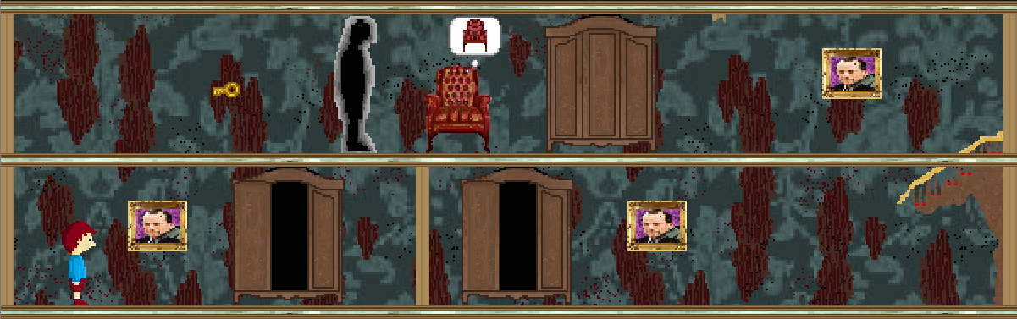

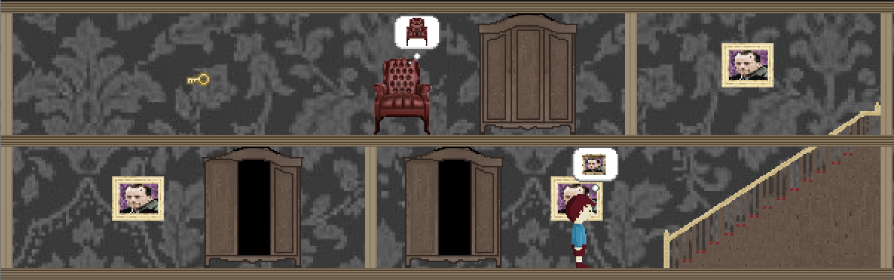

Consequentially, the state of the entire house will have changed and the player will now understand that when apparently stuck in one time frame, there is a possibility that a staircase may be repaired or a wall may be broken in a different one thus allowing the player to proceed through the level. This newly obtained knowledge will have to be used again by the player immediately upon reaching the second floor since the path is blocked by a wall. Returning to the present will clear that path, allowing Bruce to proceed to the tutorial’s final two lessons. The shadow stands between Bruce and the key to the wardrobe therefore Bruce now has to interact with the chair to lead the shadow behind the key so that Bruce can actually pick it up. Doing so will unlock the wardrobe. This will immediately attract the shadow’s attention and it will go towards the wardrobe to investigate. If the player does not respond appropriately (by dashing to the wardrobe before the shadow reaches it or by walking farther away in the opposite direction) then the threat of the monsters will be evident since the player will be forced back to the beginning of the level. Making a run for the open wardrobe will conclude the tutorial level and the player will be more independent in solving all subsequent puzzles.  
  
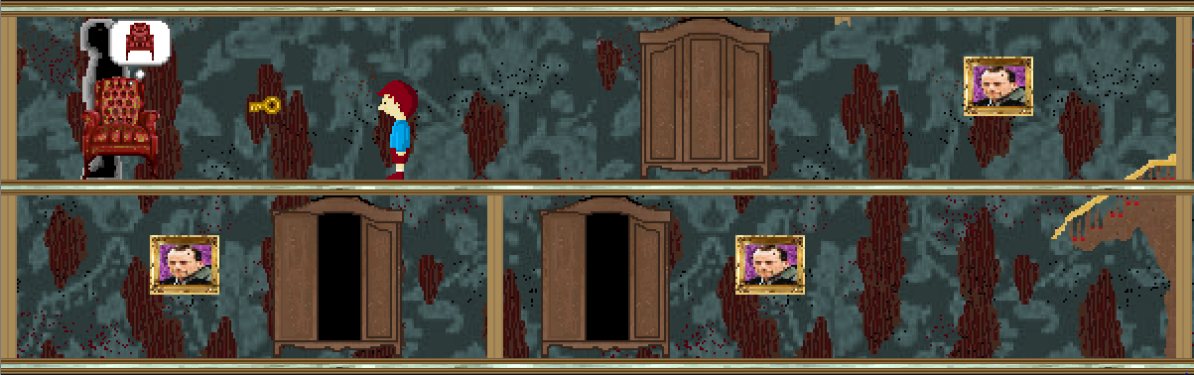

Level 1

This level is designed with one extra mechanic in mind: moving wardrobes. Although it was possible in the tutorial level, there was no need to do it. In this level though, it is crucial for Bruce’s progression. The first things that can be seen are new type of obstacles: debris and a closed door which is locked by a key which can be seen behind a wall. If the player goes back in time, the debris pile is no longer there, this allows the wardrobe to be pushed. Since the wardrobe is pushed in the past, the change affects the present.

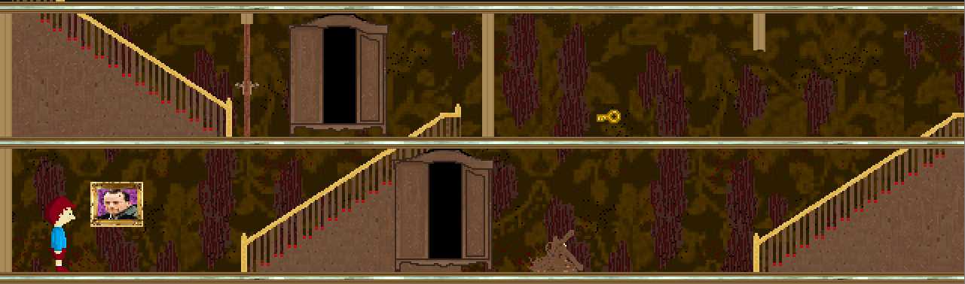

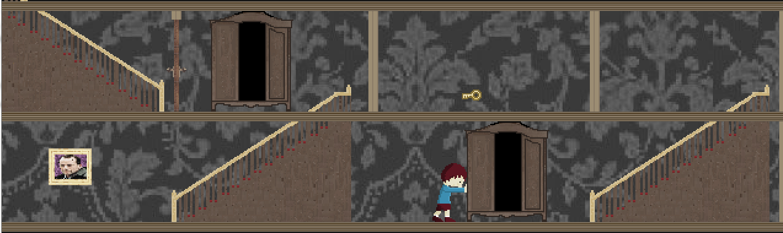

At this point, the player will understand that going up the stairs on this side in this time frame will not do much since the room with the key is closed in with intact walls. While the wall is broken in the present, the staircases, thankfully, are not. The level can now be easily solved by walking to the painting, returning to the present, going up the stairs to the other wardrobe and teleporting to the wardrobe which was moved behind the debris, going up the stairs, obtaining the key by passing through the broken wall (the door magically opens), descending the staircase to the wardrobe, teleporting to the wardrobe near the door and ascending the stairs behind the door to the next level.

The level was designed to make the player think a bit about how to solve it and then solve it without much more thought. The key to the puzzle is understanding how to use the past to get the wardrobe beyond the debris and get the key behind the wall. While this level is not very challenging, it is a way of making sure the player has understood the required mechanics to solve the puzzle with little guidance.

Level 2

The purpose of this level is to challenge the player in situations involving shadows moving in front of wardrobes when they are unlocked. Though this consequence of unlocking a wardrobe was introduced in the tutorial level, depending on how it is played, the player may have never had to recover from this situation since simply entering the wardrobe before the shadow reached it was sufficient to solve the puzzle. If not, then simply moving a chair on this floor would solve this situation. This level reproduces this situation with the absence of a chair on the floor to distract the shadow with.

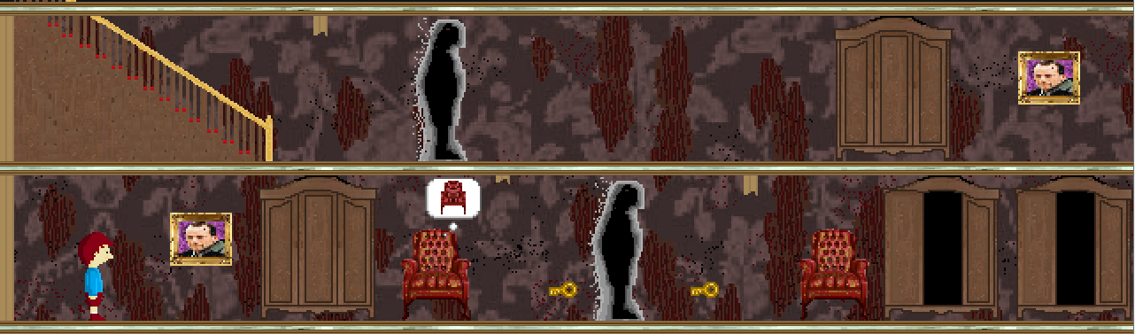

Essentially, this level only needs one chair, but a second one was added just to add a bit more of a choice for players if they don’t feel like moving one particular chair too far.

The level starts out with 2 locked wardrobes and 2 open ones. The keys to both wardrobes are guarded by a patrolling shadow on the bottom level and the top level is guarded by another such patrolling shadow. Going back in time won’t help Bruce obtain the key since the broken walls will be repaired, trapping the keys between impassable walls. To avoid accidentally being caught by the shadow while obtaining the first key, Bruce must use one of the chairs and move it behind that key. If the player is fast enough, they can make Bruce move the closest chair to the farthest side of the level to have the shadow move there. That gives Bruce enough time to grab the two keys and return to the unlocked wardrobe to teleport behind the shadow. Unfortunately, now that both Wardrobes are unlocked, both shadows stand in front of both wardrobes which makes teleportation impossible at the present moment.

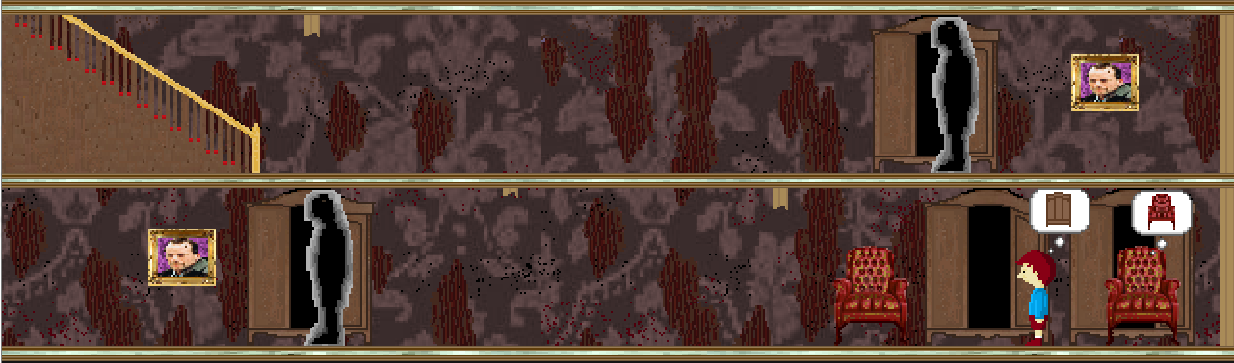

This is where the level’s challenge is really present. Moving the shadow on the bottom floor away from the wardrobe is easy since it merely involves moving one of the chairs to have it investigate. The upper shadow though is guarding the only entrance to that floor and there is no evident way of moving it. Attempting to use this wardrobe now will only lead to losing the level.

This puzzle can now be solved by using the combined mechanic of time travel and wardrobe pushing. By moving the lower shadow away from the bottom left wardrobe and far enough from the portrait will allow Bruce to go back in time to when the shadows were not present. Bruce can now safely teleport to the upper floor. Going back to the present right now wouldn’t be a smart move either since the shadow is still present in front of the wardrobe, effectively blocking the path to the exit. In the past, Bruce must push the wardrobe away from where the shadow would be in the past, the shadow would not be concerned with this change since, according to the space-time continuum, the wardrobe was always at that location.

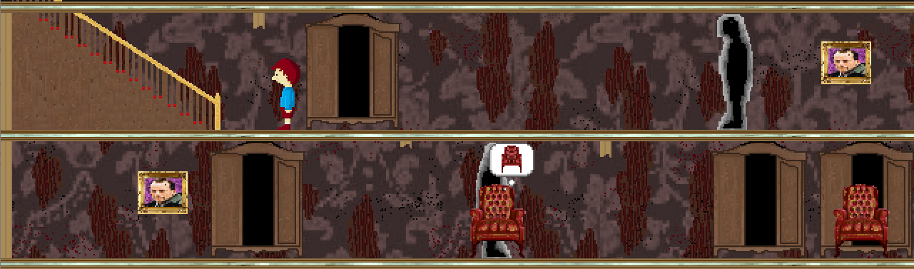

Bruce must now go back to the present, when the wall is broken to advance to the next level. To do this, the player will have to understand that the only painting that can help Bruce do that is the one on the bottom floor. Bruce must go back through the two wardrobes to his starting location, return to the present through the painting on the bottom, then go back to the top floor the same way he came. The wall is now gone and Bruce can proceed.

Level 3

This level is designed to fool the player into thinking it is a lot easier than it actually is. Though there seems to be a lot of elements in the level, there is really only one thing Bruce can do at the beginning –go through the wardrobe right in front of him.

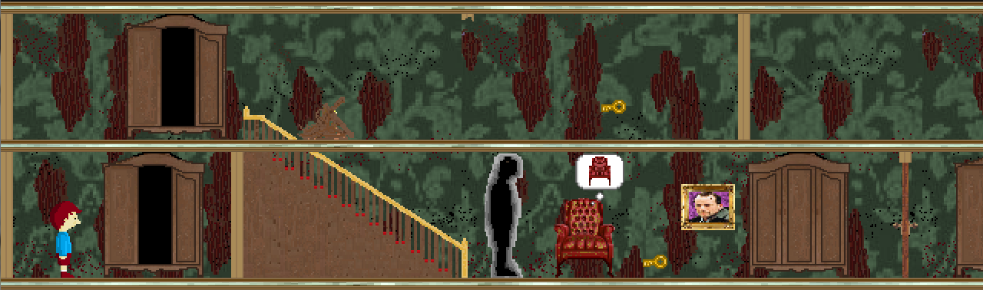

Doing that will teleport Bruce to the far side of the level which was initially not visible to the player. This is where the fooling is meant to take place. Bruce has a pile of debris between him and the level’s exit as well as an accessible portrait which should take him to the past to when the debris wasn’t there, allowing an easy path to the exit. This is perfectly good logic and clearly the only thing to do.

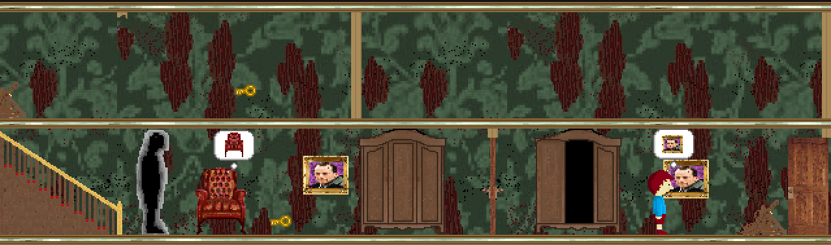

Not quite. Unknown to Bruce and completely overlooked by the man in the portrait, the portrait was moved sometime in the more recent past taking Bruce all the way back to the top left corner of the level to find an alternate way to reach the exit. 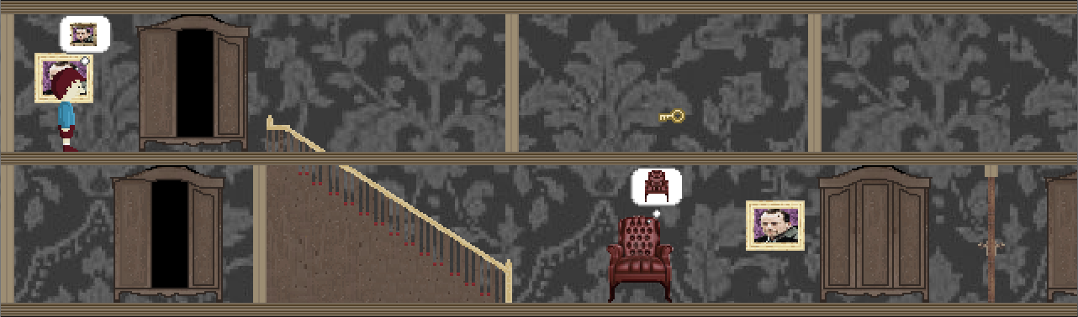

Here is what is now known: There are two keys, one which is only present in the present. One unlocks the lower door, and the other unlocks the locked wardrobe at the bottom. If the player remembers the initial layout of the level, they will remember that in the present, there is a pile of debris between the upper wardrobe and the wall on the right. To save time later, let us assume that this fact is known, and that Bruce pushes the wardrobe past where the debris will be in the present. The only thing which must can be done now is to go down the stairs and through the portrait to the present which thankfully remains in its place. Back in the present, the shadow is there, guarding the key. When the key is grabbed, the lower wardrobe will unlock opening a path to the upper wardrobe but the shadow will dash towards the newly unlocked wardrobe to investigate giving Bruce little time react. The easiest way to recover from this situation is to immediately interact with the chair and move it slightly to attract the shadow’s attention. Bruce can now teleport to the upper level, grab the key to the door by passing the broken wall, teleport back down, and go back in time to have the rubble from the beginning of the level cleared. We can now be in front of the exit in the past and exit the level without a problem.

In total, this level’s solution involves very few steps. However, the moving portrait does cause a bit of confusion so it may take the player some time to figure it out. The portrait’s sarcastic apology for his memory lapse also adds a bit of humor to this level as well. The perceived difficulty of this level also increases since it seemed like it was a lot easier at the beginning only to add the ridiculous detour moments later.

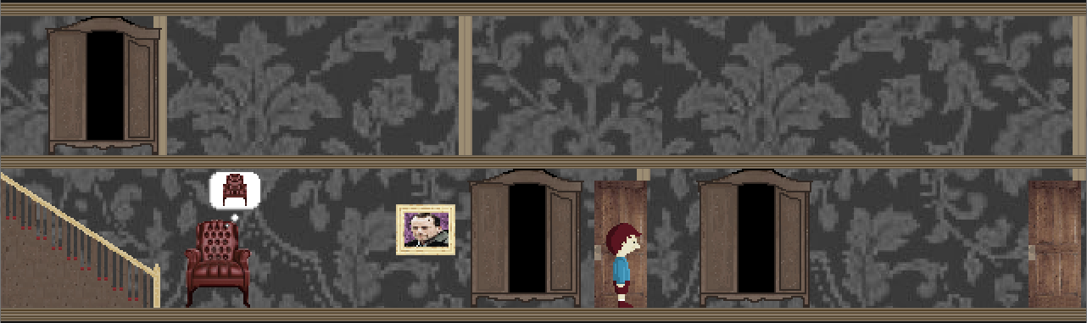

Level 4

This level introduces new twists to the game’s original mechanics. There are now two versions of the past – the older one being remembered by the portrait of a woman which was not present in earlier levels. The level also allows Bruce to use the shadows as some form of environmental ally. The level starts one of two ways which don’t really make any difference. If the level is reached through the completion of Level 3 then Bruce will start out in the past but must return to the present through the painting in the beginning to properly proceed. If the level is accessed through the level selection menu, then Bruce starts out in the present.

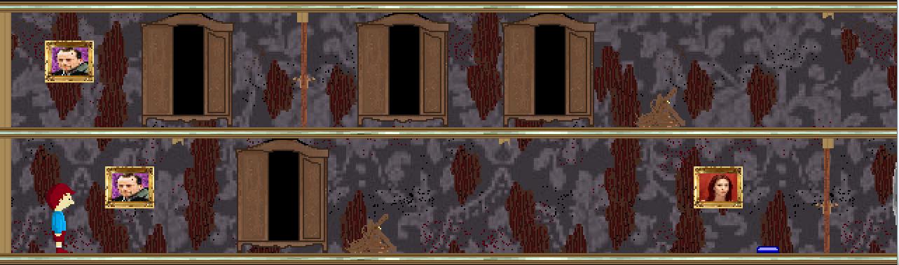

Going to the past from here will do nothing since there will be a wall blocking the path. There is also a pile of debris which, though not present in the past, blocks the path in the present. Bruce has no choice but to enter the wardrobe and be transported to the floor right above. From here, the only logical thing to do is go back to the past from the portrait on this floor. This will lead to the rubble below being out of the way, even though the wall which is broken was still intact. Regardless, the player will eventually understand that Bruce must move the wardrobe past the rubble then go back in the present to pass the wall where he will encounter the portrait of the woman who remembers the house while it was being built, and the mechanic involving the buttons which must be stepped on is introduced. Bruce must somehow lead the shadowy figures to step on the buttons simultaneously to open a secret passage somewhere in the level.

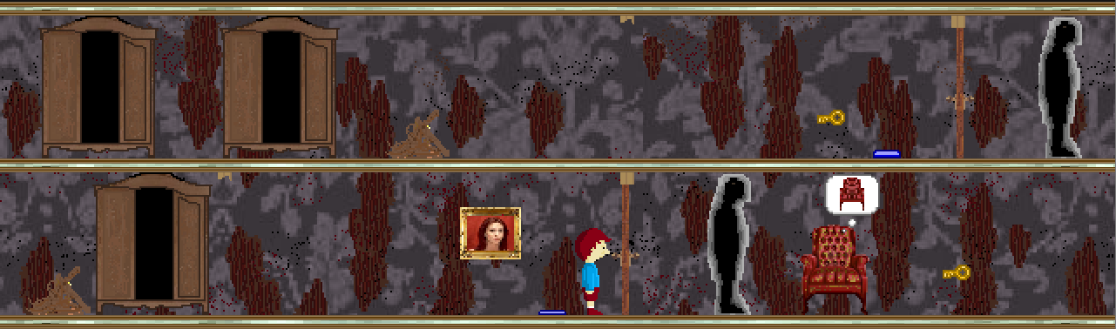

Stepping on the button alone will not do anything, so the player will understand that the only way to progress now is to go through the woman’s portrait only to discover yet another even older past.  
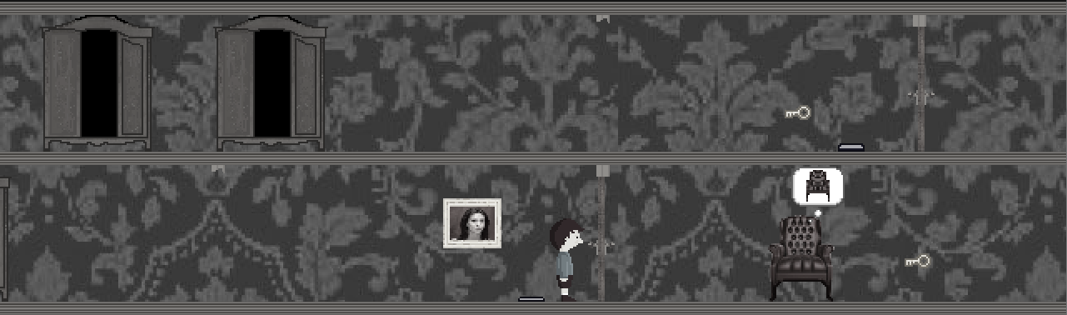

The first thing that will be noticed is that the wardrobe that was recently moved is back in its original place since this past is older therefore the changes to wardrobes made in the more recent past do not affect this one. Bruce must thus go back to wardrobe and move it forward near the woman’s portrait (something which could not be done before due to the hindrance of the wall and debris). Also visible, is the fact that the man’s portraits are no longer present. This (along with the more greyscale color tone) shows the player that this past is in fact older. The player will surely feel stuck since both doors are still locked but by moving the wardrobe to this location, Bruce can now access this room in all time frames. Bruce will thus need to go back to the present, teleport to the top floor, access the man’s portrait to the more recent past where the key is found near the woman’s portrait. By teleporting to the bottom floor, Bruce can acquire that key and unlock the door on the upper floor.

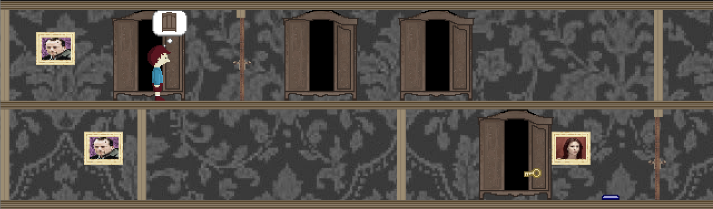

Bruce can now walk through the unlocked door to the two side-by-side wardrobes. In the present, there is a pile of debris between the wardrobes and the wall and the only way to cross the far wall is when it is broken in the present. So Bruce has to utilize the past state to push one of the wardrobes past where the debris will be in the present then go back to the present through the portrait. Then Bruce can easily teleport across the debris and walk through the broken wall and obtain the now visible key which unlocks the door downstairs.

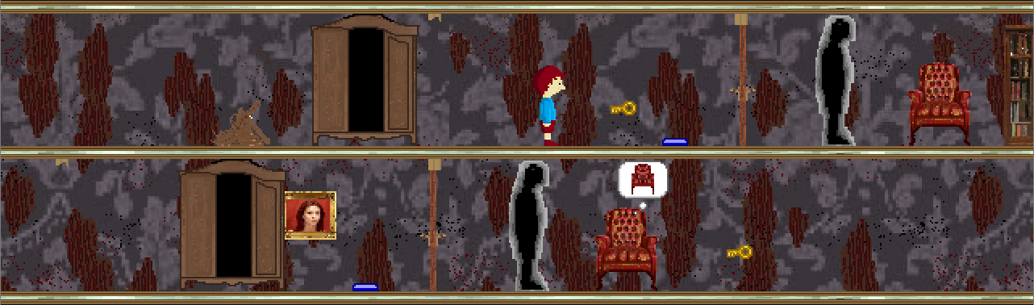

From here the player can see the final key which is located on the bottom door behind a guarding shadow. Bruce can levitate the chair and move it far behind the key in order to attract the shadow away from the key. Once this is done, Bruce must retrace his steps to the bottom floor and obtain the key which will unlock the final room with the bookcase. To get through the secret passage behind the bookcase, the player will have to know how to get the shadows to stand on the blue buttons. The key to that is the chairs. The first one is easy and won’t be much of a challenge to players. After having obtained the key, from anywhere within reach of the bottom chair, Bruce can simply move the chair on top of the button and the bottom shadow will move to that location.

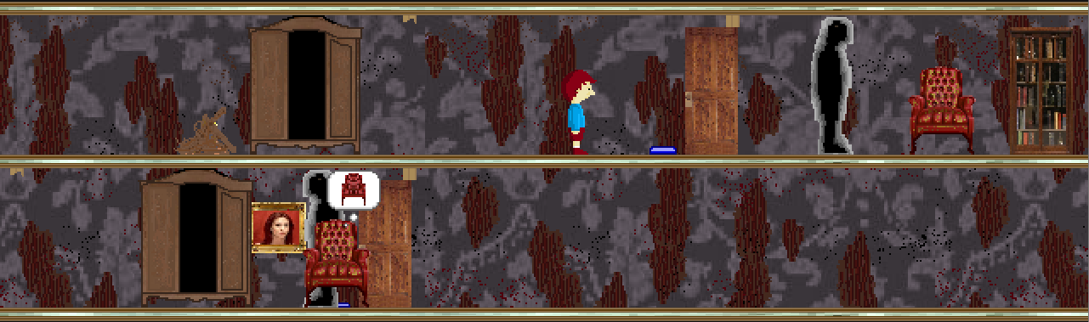

The next button is slightly trickier since both the bookcase is behind the shadow and there is no way of pushing the wardrobe behind the shadow in any other time frame. Although there is more than one way of getting behind the shadow, the level was designed with this solution in mind: Bruce must push the nearest wardrobe as close as possible to the door, levitate the chair and drop it somewhere between the wardrobe and the debris. As the shadow moves to investigate the chair, Bruce must teleport through the wardrobe and wait for the shadow to clear the wardrobe’s entrance before returning. At this point Bruce can simply enter the final room, levitate the chair and place it on the button, making the shadow stand on the second button, thereby opening the secret passage behind the bookcase.

Bruce can proceed through this final passage to end the game.

**Mechanics analysis**

As a puzzle game, *Continuum*'s main mechanic is the puzzle solving mechanic. The game is laid out as one large area subdivided into discrete puzzles that are completed sequentially. To progress in the game, the player must solve these discrete puzzles using the items at their disposal. The beginning of each puzzle serves as a checkpoint, meaning that any failure to complete the puzzle will result in its recommencement at the start of the level. Each puzzle offers the player a new challenge based on the discovery of a new ability, the introduction of a new hazard or the existence of a new tool.

The breakdown of the game into many discrete levels is not a new idea and is found in such puzzle games as the *Portal* series. Just like in *Continuum*, *Portal* is broken down into different test chambers that are completed sequentially. There are a few advantages to this structure. The first is that it helps the player focus on what has to be done next. With small discrete puzzles, the player knows that everything needed to solve the puzzle is found in the puzzle; if the player gets stuck, he will not wonder whether or not he missed some item in an earlier level or did not learn some ability that he was supposed to before reaching this current point. The player can be confident that the puzzle can be solved, and can focus on the challenge at hand rather than trying to remember everything about the game world. A second main advantage is that the increase in puzzle difficulty can be very easily controlled. The player is forced to complete the tutorial puzzle, then puzzle one, followed by puzzle two, and so on. Because of this game structure, the increase in perceived difficulty as the game progresses can be easily controlled. If the jump in difficulty from one level to another is too great, the difficulty of one of the two levels can simply be adjusted. In a less linear and discrete game, adjusting the change in difficulty is more complicated as it depends on the order in which the player completes the game's challenges. For example, in a completely free-roaming game, the player could access an area before he is expected to, thus increasing the difficulty of the game too rapidly. A discrete and sequential breakdown prevents this from happening. Finally, discrete puzzles prevent time wasting. Nothing is more frustrating in a puzzle game than knowing what has to be done but having to wait a long time before being able to do it. The discrete breakdown of the game means that individual puzzles are significantly smaller than the total size of the game. If the player needs to use an item at the beginning of the puzzle, he won't waste much time getting there. On the other hand, if a large continuous structure was used, the player might have to go back to the beginning of the game to solve a puzzle, wasting a lot of time walking there. With small levels, we ensure that a minimum amount of time will be wasted, meaning that players will spend more time determining the steps to complete a puzzle than completing them. For all of these reasons, a discrete breakdown of the game was chosen over a large continuous structure.

Each of the unique game mechanics in *Continuum* also relate to its main overarching puzzle mechanic. Because puzzle solving is the only real focus of *Continuum*, each puzzle solving item or ability must also be treated as a separate mechanic. These mechanics include the portraits, the wardrobes, the shadows and the obstacles (doors, walls rubble and staircases).

The portraits constitute one of the two primary puzzle solving mechanics in *Continuum* and probably provide the game's most original mechanic. Quite simply, portraits allow the player to travel in time. By entering a portrait, the player travels back to the most distant period of time that the person in the portrait remembers. By re-entering the portrait or any other portrait belonging to that person in the past, the player is brought back to the present. This mechanic allows the player to dynamically alter the state of the house, as a room may have changed over time. For example, a staircase that was once intact may be broken in the present. This portrait allows the player to access new locations by "repairing" staircases, "breaking" walls or "clearing" rubble. In addition, any actions carried out in the past will have an effect on the present, but actions in the present will have no effect on the past. In the case of multiple pasts due to multiple portraits (near past and far past), changes in the far past will affect the near past and the present while changes in the near past will only affect the present. This means that objects can be in different locations at various points in time. The portrait time-travel mechanic is unique and the developers do not know of any other game that employs it. Given that this is one of the defining mechanics of *Continuum*, no alternatives were ever explored. The most difficult part of using the time travel mechanic was balancing the distant past. The problem with the distant past is that it removes most obstacles: walls have not been built yet, rubble piles don't exist, etc. As such, developers had to be careful not to accidentally create shortcuts when employing the far past and had to make sure to design puzzles that would not become trivial with its existence.

The wardrobes constitute the other main puzzle solving mechanics in *Continuum*. Wardrobes are scattered throughout the levels and are used by the players as teleportation devices. By entering a wardrobe, the player will exit its matching wardrobe. To expand gameplay, wardrobes can be pushed to different locations by the player and may also be locked. Pushing the wardrobes to different locations allows for the player access different areas of the room, and because of the two or three different time states, moving the wardrobe in the past will change its position in the future. This allows for the player to access new areas by constantly travelling back and forth in time. Wardrobes may also be locked, meaning that players must first unlock the wardrobe before being able to use both the locked wardrobe and its matching wardrobe. This wardrobe mechanic bears most resemblance to the portals in the *Portal* series. Because *Continuum* started off primarily as a set of different mechanics, wardrobes were one of the founding features of the game and alternatives were never truly considered.

Shadows constitute another key puzzle solving mechanic in *Continuum*. The shadow is the only object in the game that can "harm" the player, but only exists in the present state of the house. If the player bumps into a shadow, he will have to restart the level. The idea behind this is that the shadow is a human that has entered the house. While the human cannot see the player, the human will feel the player if he tries to walk through him. Because the player is trying to remain inconspicuous, he must not bump into a shadow. Given that the player has no weapons, he cannot attack the shadow but must instead avoid it. This is done by either distracting it or by entering the past to get rid of it. The shadow can be distracted by moving chairs. If Bruce moves a chair across the room, the shadow will become interested in its sudden unexplained movement and will follow it. However, the shadow will also react to wardrobes being unlocked and will move towards them to investigate. The idea of a constant threat that the player cannot attack is featured in many games and is reminiscent of *Resident Evil 3*'s Nemesis. The shadow is probably the element featured in *Continuum* that changed the most. Originally, there was only going to be one shadow that would constantly follow the player around the house. If the shadow started to get too close, the player could attack it with a special furniture attack. First, the idea to have the shadow constantly follow the player around was dropped for two reasons: developers felt that it would detract from the puzzle side of the game and would put too much pressure on the player. Later, the idea to have the player attack the shadow was also dropped for a similar reason: given that the game was primarily a puzzle based game, developers felt that having a single action element would be strange. This thought was re-iterated by those who attended the game's proposal. In the end, the shadow became simply a dynamic puzzle element.

While the shadow is essentially a moving obstacle, there are static obstacles in *Continuum* as well. The obstacles constitute a very simple but important element of *Continuum*. The ideas of switching between the past and the present as well as moving wardrobes around are nothing without obstacles that force the characters to employ these mechanics. The obstacles in *Continuum* stop players from advancing to the next destination, and as such are actually the foundation of all puzzles in the game. In order to balance the difficulty of advancement between the past and the present, obstacles were created employing a somewhat zero-sum approach. The idea is that for every obstacle that disappears by switching state, a new one appears. This is achieved with the walls and the rubble, which alternate in existence based on the state that the player is in. Staircases can be broken in the game but more often than not are intact in both states to maintain the zero-sum idea. The doors on the other hand constitute simple obstacles in both states and must be unlocked with keys. All of these obstacles are very common and can be found in many games from the *Mario Bros.* series to *Resident Evil*. The only alternative was to have a hole in the floor instead of a rubble pile, but this was removed for a few reasons. First, the two obstacles essentially behaved in the same way, but the player would expect to be able to fall through a hole. Because Bruce is actually a ghost, falling from one floor to the next would not kill him, leading to an accidental revelation of his nature. Second, players would be able to move chairs from one floor to another using the holes in the floor, and the developers did not want that to be a possibility. As such, rubble piles were chosen over holes.

Player movement is another mechanic found in *Continuum*. The player moves according to classic platform mechanics, moving horizontally with the left analog stick and vertically only by interacting with staircases. Because the focus in *Continuum* is on puzzle solving, the movement was designed to be extremely simple as not to get in the way. The developers wanted the player to focus on solving the puzzles using the items at their disposal, not using movement mechanics. As such, the player is not even given the ability to jump, preventing him from trying to find a shortcut around a puzzle. *Continuum*'s movement was designed to be as intuitive as possible, and the simple control scheme was agreed upon as a result. A point and click movement scheme could have worked stylistically with the game. However, given that the game was being developed for the Xbox 360, a simple point and click movement mechanic would have been impossible. The only other variation that was discussed was using the analog stick to interact with the staircase rather than the interaction button. However, this was not employed for simplicity and consistency reasons. By using the interaction button, the game employs a consistent rule that any interaction with an object must be done with the interaction button.

**Schedule**

July 4: Start of development cycle.

July 16: Game proposal submission and project presentation.

July 17: Coding begins.

July 28: Demo feature freeze.

July 30, 10:00: Demo Code freeze.

July 30, 11:45: Demo presentation.

August 5: Feature freeze.

August 12: Playable game complete. Continuous testing and debugging.

August 13, 14:30: Code freeze, final deployment and presentation.

August 13, 23:55: Final submission.

**Budget**

The cost associated to the development of the game includes the software used and the team salary. The software tools and licenses used are approximated to visual studio price ($499.99) since all other tools used are free under GNU Licenses. The salary is based on actual junior software engineering wage; that is approximately $25 per hour for each member of the team.

We first estimate the team’s salary within the table below that is broken down into the three phases according to the project presentation. A separate column is given for total cost and descriptions about the time estimation. The overall development cost is $20,099.99.

|  |  |  |  |  |
| --- | --- | --- | --- | --- |
| Artifacts | Phase 1 Cost (Time in hours) | Phase 2 Cost (Time in hours) | Phase 3 Cost (Time in hours) | Descriptions/Total Cost (Dollars) |
| Project Proposal | 10 | 0 | 0 | Time used to brainstorm the game idea |
| Project Progress | 0 | 96 | 0 | From the game idea to the prototype |
| Project  Deliverables | 0 | 0 | 196 | From the prototype to the final product |
|  |  |  |  |  |
| Total | 10 | 96 | 196 | $19,600 |

We then estimate the game’s lines of code to 3,000 based on previous experience and construct this budget model using **COCOMO II (Constructive Cost Model)** for equivalent software size (3000 Lines of Code).

**13 persons/months effort required**

**9 months schedule**

**Total cost of 49,172$**

**See more details below:**

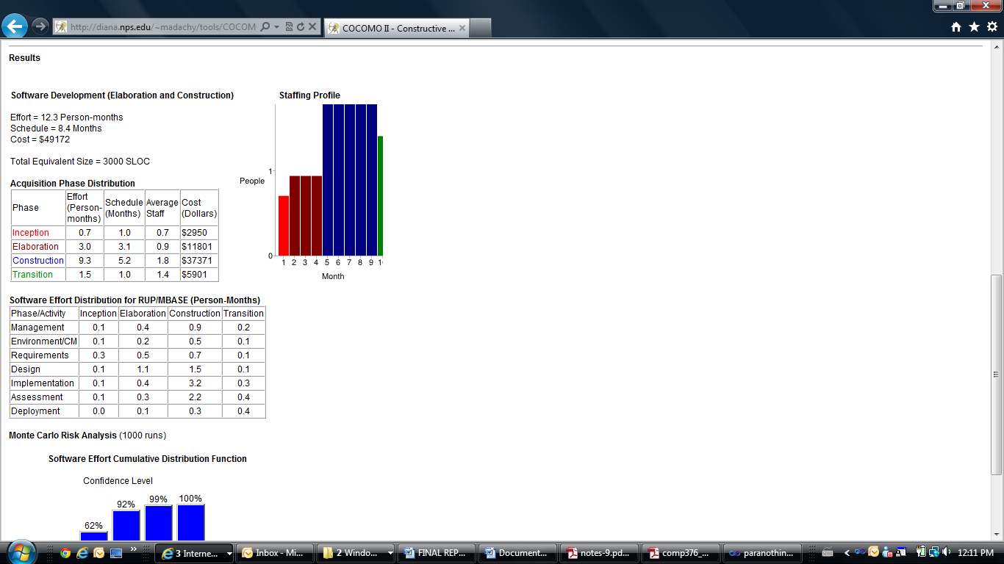

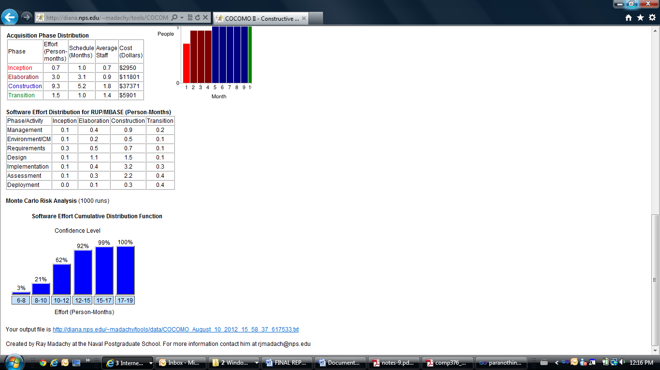

**Change log**

Alex Attar has joined the development team.

The mechanic of mirrors altering the world has been removed due to time and lack of implementation ideas. Mirrors will now simply be a static background object.

The mechanic of the player being equipped with a flashlight to fight off monsters has been removed due to mirrors being removed as well as a change in the game’s fiction. Since the character is a ghost, there is no good reason for him to be equipped with a flashlight.

The ability of the house to have multiple past states has been added with a separate portrait to complement this new feature.

Buttons on the floor to unlock a secret passage behind a bookcase has been added to the last level’s design.

Engaging the enemies with the chairs has been changed to simply distracting the enemies in order to give chairs a more important puzzle-solving role.

The amount of back-story that will be presented in the game has reduced in relation to the game's length.